

oneM2M
Technical Report
Document Number | oneM2M-TR-0018-V-0.3.0
Document Name: | Industrial Domain Enablement
Date: | 2015-Aug-14
Abstract: | This oneM2M Technical Report collects the use cases of the industrial domain and the requirements needed to support the use cases collectivly. Furthermore, the Technical Report also identifies necessary technical works need to be addressed while enhancing the oneM2M specifications in the future.

This Specification is provided for future development work within oneM2M only. The Partners accept no liability for any use of this Specification.
The present document has not been subject to any approval process by the oneM2M Partners Type 1. Published oneM2M specifications and reports for implementation should be obtained via the oneM2M Partners' Publications Offices.

About oneM2M
The purpose and goal of oneM2M is to develop technical specifications which address the need for a common M2M Service Layer that can be readily embedded within various hardware and software, and relied upon to connect the myriad of devices in the field with M2M application servers worldwide.
More information about oneM2M may be found at: http//www.oneM2M.org
Copyright Notification
© 2015, oneM2M Partners Type 1 (ARIB, ATIS, CCSA, ETSI, TIA, TTA, TTC).
All rights reserved.
The copyright and the foregoing restriction extend to reproduction in all media.

Notice of Disclaimer & Limitation of Liability
The information provided in this document is directed solely to professionals who have the appropriate degree of experience to understand and interpret its contents in accordance with generally accepted engineering or other professional standards and applicable regulations. No recommendation as to products or vendors is made or should be implied.
NO REPRESENTATION OR WARRANTY IS MADE THAT THE INFORMATION IS TECHNICALLY ACCURATE OR SUFFICIENT OR CONFORMS TO ANY STATUTE, GOVERNMENTAL RULE OR REGULATION, AND FURTHER, NO REPRESENTATION OR WARRANTY IS MADE OF MERCHANTABILITY OR FITNESS FOR ANY PARTICULAR PURPOSE OR AGAINST INFRINGEMENT OF INTELLECTUAL PROPERTY RIGHTS. NO oneM2M PARTNER TYPE 1 SHALL BE LIABLE, BEYOND THE AMOUNT OF ANY SUM RECEIVED IN PAYMENT BY THAT PARTNER FOR THIS DOCUMENT, WITH RESPECT TO ANY CLAIM, AND IN NO EVENT SHALL oneM2M BE LIABLE FOR LOST PROFITS OR OTHER INCIDENTAL OR CONSEQUENTIAL DAMAGES. oneM2M EXPRESSLY ADVISES ANY AND ALL USE OF OR RELIANCE UPON THIS INFORMATION PROVIDED IN THIS DOCUMENT IS AT THE RISK OF THE USER.

Contents
Contents 3
1 Scope 4
2 References 4
2.1 Normative references 4
2.2 Informative references 4
3 Definitions, symbols, abbreviations and acronyms 4
3.1 Definitions 4
3.2 Symbols 4
3.3 Abbreviations 5
3.4 Acronyms 5
4 Conventions, 5
5 Introduction to Industrial Domain 5
5.1 Industrial Domain Overview 5
5.2 Technology Trends in Industrial Domain 5
6 Use Cases 6
7 Overview of Potential Requirements 6
8 High Level Architecture 6
9 Security Analysis 6
10 Conclusion 6
Proforma copyright release text block 6
Annexes 6
Annex <y>: Bibliography 7
History 7

1 Scope
This Technical Report collects the use cases of the industrial domain and the requirements needed to support the use cases collectivly. Furthermore, the Technical Report also identifies necessary technical works need to be addressed while enhancing the oneM2M specifications in the future.

2 References
References are either specific (identified by date of publication and/or edition number or version number) or non-specific. For specific references,only the cited version applies. For non-specific references, the latest version of the referenced document (including any amendments) applies.

2.1 Normative references
Not applicable.

2.2 Informative references
The following referenced documents are not necessary for the application of the present document but they assist the user with regard to a particular subject area.
[i.1] oneM2M Drafting Rules
[i.2] oneM2M TS0011, “Definitions and Acronyms”

3 Definitions, symbols, abbreviations and acronyms
For the purposes of the present document, the terms and definitions given in oneM2M TS0011, “Definitions and Acronyms” [i.2] and the following apply. A term defined in the present document takes precedence over the definition of the same term, if any, in [i.2].

3.1 Definitions

3.2 Symbols
Clause numbering depends on applicability.
For the purposes of the present document, the [following] symbols [given in ... and the following] apply:
Symbol format
<symbol> <Explanation>
<2nd symbol> <2nd Explanation>
<3rd symbol> <3rd Explanation>

3.3 Abbreviations
Abbreviations should be ordered alphabetically.
Clause numbering depends on applicability.
For the purposes of the present document, the [following] abbreviations [given in ... and the following] apply:
Abbreviation format
<ABBREVIATION1> <Explanation>
<ABBREVIATION2> <Explanation>
<ABBREVIATION3> <Explanation>

3.4 Acronyms
Acronyms should be ordered alphabetically.
Clause numbering depends on applicability.
For the purposes of the present document, the [following] abbreviations [given in ... and the following] apply:
Acronym format
<ACRONYM1> <Explanation>
<ACRONYM2> <Explanation>
<ACRONYM3> <Explanation>

4 Conventions,
The key words “Shall”, ”Shall not”, “May”, ”Need not”, “Should”, ”Should not” in this document are to be interpreted as described in the oneM2M Drafting Rules [i.1]

5 Introduction to Industrial Domain
<Text>

5.1 Industrial Domain Overview

In previous industrial domain, the information exchange from factory-to-factory or centre-to-factory needs support from human. Normally the exchange is non-synchronous, discrete and inefficient to be unable to achieve the capacity to respond rapidly to market changes.
Currently M2M technologies are considered to achieve the communication and interaction from machine-to-machine without human’s support. It brings opportunities to achieve synchronous, continuous and effective information exchange in manufacturing. Based on M2M, new manufacturing method can be suitable for increasing complex requirements of future market.
Many industrial companies have been aware of the potential power to update traditional manufacturing system by introducing M2M technologies, not only because of the technical requirements such as improving the performance of productivity, quality, delivery, cost reduction and security, but also new opportunities to cooperate with other domains for mass production, and furthermore, to build the new architecture for next generation industry. Figure 5.1-1 is an example architecture.

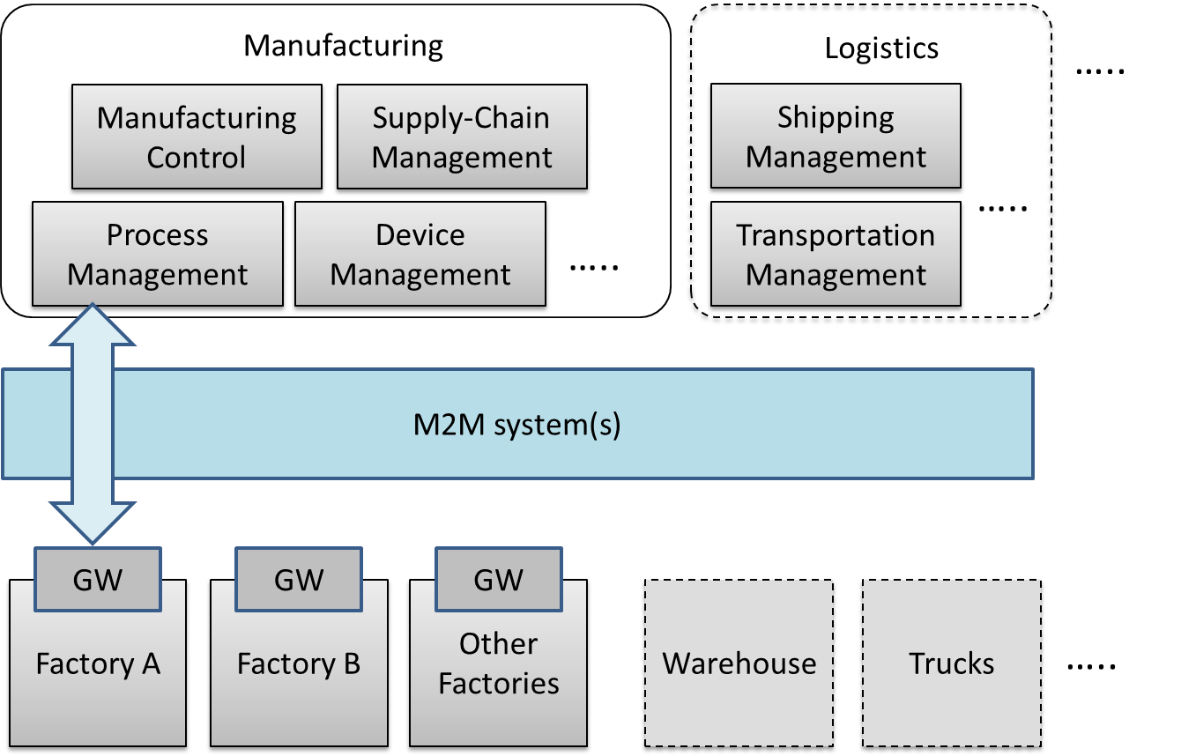

Figure 5.1-1 Industrial Domain Architecture

In Figure 5.1-1, factories will be connected with manufacturing services via M2M system(s). Generally, the gateway in factory will collect data from factory and send to manufacturing services in management centre. The service will be initiated by different management modules and sent to factories.
In addition, with the M2M system(s), the complex service can be sent to several factories synchronously, to realize the effective collaborations between factories. Every factory is expected be able to make accurate decisions and to do effective operation, because it can work based on analysis result from data of all factories rather than from itself. Management centre with manufacturing services also is expected to be able to make accurate decision by utilizing field data of all factories, and also via other support, such as cloud computing, to improve efficiency of local or global services.
In the future, if more and more industry related domains, such as logistics and power management system, can be connected into the M2M system, resources (warehouses, trucks, ships, power, etc.) can be integrated efficiently. Therefore more flexible services will be created to face the complex situation.
As oneM2M architecture provides general Application Layer, Common Services Layer and the Underlying Network Services Layer, and will be connected with other vertical systems, it is meaningful to consider the integration of industrial domain system with the oneM2M architecture.

Editor’s note: paragraph is expected to show the role of oneM2M.

5.2 Technology Trends in Industrial Domain
To accelerate the update of manufacturing systems, many worldwide organizations have been established and started making efforts.
In IEC (International Electrotechnical Commission), Standardization Management Board (SMB) of IEC set up a Strategy Group, SG8 to deal with a number of tasks related to Smart Manufacturing on June 2014. ^{[1]}
Table 5.2-1 Industrial Domain Research in IEC SMB SG8 ^{[2]}
Mission & Scope | • Develp a function model/reference architecture that helps to identify gaps in standardization based on to-be-collected use cases  • Develop a common strategy for the implementation of Industry 4.0  • Extend standards towards: environmental conditions, security, properties, energy efficiency, product and functional safety
Technical Keywords | • Industrial process measurement, control and automation  • Application: semantics relationships descriptive technologies  • Services: web services /SOA repositories /clouds dependable connections  • Communication: data access real-time communications

IIC (Industrial Internet Consortium) was founded in March 2014 to bring together the organizations and technologies necessary to accelerate growth of the Industrial Internet by identifying, assembling and promoting best practices. ^{[3]}
Table 5.2-2 Industrial Domain Research in IIC ^{[4] [5]}
Mission & Scope | • Productivity and efficiencies can be improved by production process governing themselves with intelligent machines and devices  • Real time data report from handheld digital device  • Wearable sensors track location of employees in case of emergency  • Future scenarios: new steering instruments will interlink things to ensure the entire value chain and trigger adjustments on the factory floor in case of chain changing; raw materials will be programmed to record standard process and their customer to realize automatic customization.
Technical Keywords | • Representative use case areas include connectivity, logistics, transportation, and healthcare  • Key capabilities system characteristics including resilience, safety and security. (such as key system characteristic, intelligent and resilient control, operations support, connectivity, integration and orchestration, security, trust and privacy, and business viewpoint)  • Data management and analytics  • Security: endpoint security, secure communications and security management and monitoring (currently focused on general security use case)

IEEE P2413 defines an architectural framework for the Internet of Things (IoT), including descriptions of various IoT domains including industrial domain and is sponsored by the IEEE-SA. ^{[6]}
Table 5.2-3 Industrial Domain Research in IEEE P2413 ^{[7] [8]}
Mission & Scope | • Ranges from the connected consumer to smart home & buildings, e-health, smart grids, next generation manufacturing and smart cities  • Promote cross-domain interaction instead of being confined to specific domains
Technical Keywords | • Energy efficiency during data transmission  • Areas of interest: industrial Internet, cross sector common areas, common architecture, security safety privacy

SMLC (Smart Manufacturing Leadership Coalition) is a non-profit organization committed to the development and deployment of Smart Manufacturing Systems. SMLC activities are built around industry-driven development, application and scaling of a shared infrastructure that will achieve economic-wide impact and manufacturing innovation. ^{[9]}
Table 5.2-4 Industrial Domain Research in SMLC ^{[10]}
Mission & Scope | • To build a cloud-based, open-architecture platform that integrates existing and future plant level data, simulations and systems across manufacturing seams and orchestrate business real time action.
Technical Keywords | • Cloud-based networked data  • Enterprise real-time  • Plant level data  • Information & action  • Security

Based on the information above and current oneM2M architecture, below techology trends are becoming more and more important:
- Data management and analytics
In some industrial organizations, data management and data analytics are independent layers for data processing (such as filtering and catalogue management) and data analytics. Since large amounts of data are generating in industrial scenarios, further functionality design for data management and data analytics CSFs may need to be considered in oneM2M.
- Real-time command and control
M2M technologies enabled real-time response manufacturing practices in complex supplier networks. Realizing real-time command and control by highly available and time critical technologies will bring benefits to process automation and supply chains optimization. Use cases with real-time command and control feature may need to be considered in oneM2M. Additionally, requirements from these use cases may need to be noticed.
- Connectivity
Since connectivity in industrial domain must co-exist and evolve with legacy protocols, legacy connectivity (both wired and wireless) and legacy wiring, connectivity for manufacturing processes need to be considered, which may impact on NSE functionalities.
- Security
Increased networking and wireless technologies are the main security concerns for industrial companies. Undoubtedly, the risk trade-off will not stop companies from manufacturing evolution. Thus a renewed risk management and security ensuring for industrial domain may need to be considered.
Meanwhile more trends such as web services over M2M devices and protocols in industrial domain will be further tracked and analyzed.

Reference
- IEC TC News, http://www.iec.ch/tcnews/2014/tcnews_0214.htm
- http://www.is-inotek.or.jp/archive/05_Ishikuma_Smart_Manufacturing.pdf, Dec 2014.
- IIC website, http://www.industrialinternetconsortium.org/
- IIC document ‘Engineering: The First Steps’, Sep 2014.
- IIC report ‘Engineering Update: November 2014’, Nov 2014.
- IEEE P2413 website, http://grouper.ieee.org/groups/2413/
- IEEE P2413 presentation ‘Standard for an Architectural Framework for the Internet of Things (IoT)’, Sep 2014.
- IEEE P2413 report ‘oneM2M Specification Comment Collection’, Oct 2014.
- SMLC website, https://smartmanufacturingcoalition.org/
- SMLC presentation, https://smartmanufacturingcoalition.org/sites/default/files/savannah_rivers_03-10-2014.pdf, March 2014.

6 Use Cases
<Text> memo: Convert use cases in ppt at REQ on 19th January into oneM2M use case format.

6.1 An industrial use case for on-demand data collection for factories

6.1.1 Description
In factories, a lot of data are created from Programmable logic controllers (PLCs) every second and data are utilised to monitor production lines. These data are available via industrial bus systems, e.g. Real-time Ethernet. In order to monitor remotely, data are gathered by the M2M service platform, that needs to interface with such industrial bus systems via M2M gateways. However, it is difficult to gather all data to M2M service platform because sometimes more than 1M bit data are created per second. In such cases, only necessary data are gathered depending on situations and filtering / pre-processing of the raw data needs to be performed at the gateway.
This use case proposes that the oneM2M System offers pre-processing capabilities, e.g. rule-based collection policies (averages, thresholds …). These rules (e.g. in XML format) are called “data catalogues”.

6.1.2 Source
Hitachi

6.1.3 Actors
- PLC (Programmable logic controller): It controls sensors and devices in a production line according to embedded programs. It also has interface to Real-time Ethernet. It broadcasts data related to the production line to Real-time Ethernet.
- M2M Gateway: It provides an interface from the Real-time Ethernet to the OneM2M System. An application on the gateway collects necessary data from Real-time Ethernet according to the configuration called data catalogue, and send collected/pre-processed data to M2M service platform.
- M2M service platform: It stores data gathered from gateway(s), and provide data to applications. It also manages data catalogue in gateway(s).
- Application: An M2M Application in the Infrastructure Domain that monitors production lines by using collected data in M2M service platform, and send change request of data catalogue depending on situations.
- Real-time Ethernet: A technology standardized in IEC TC65. Ethernet is used at physical layer, but upper protocol is designed for industry purpose. In this use case, broad cast protocol is assumed. On top of Ethernet cable, data are broadcasted with ID. Address configuration is not necessary here.
- Internet connection: M2M service platform and gateway(s) are connected by the Internet physically.

6.1.4 Pre-conditions
- PLCs and gateway are connected to Real-time Ethernet. PLCs broadcast data to Real-time Ethernet. Gateway is configured to pick up necessary data from Real-time Ethernet.
- On top of the internet, VPN connection is established between M2M service platform and gateway(s).
- The data catalogue is managed by M2M service platform

6.1.5 Triggers
- Data catalogue is configured for gateway to pick up data in the Real-time Ethernet

6.1.6 Normal Flow
- Gateway picks up broadcasted data. It picks up only data that matches condition described in the data catalogue. If data does not match the condition, gateway neglects the data.
- Gateway send collected data to M2M service platform.
- M2M service platform receives data and store.
- Application utilise the data. For example, it monitors the status of production line.
- If application user finds some trouble in a production line, he/she changes the data catalogue in M2M service platform to collect all data related to the production line, and sends the data catalogue to the target gateway.

6.1.7 Alternative Flow
None

6.1.8 Post-conditions
None

6.1.9 High Level Illustration

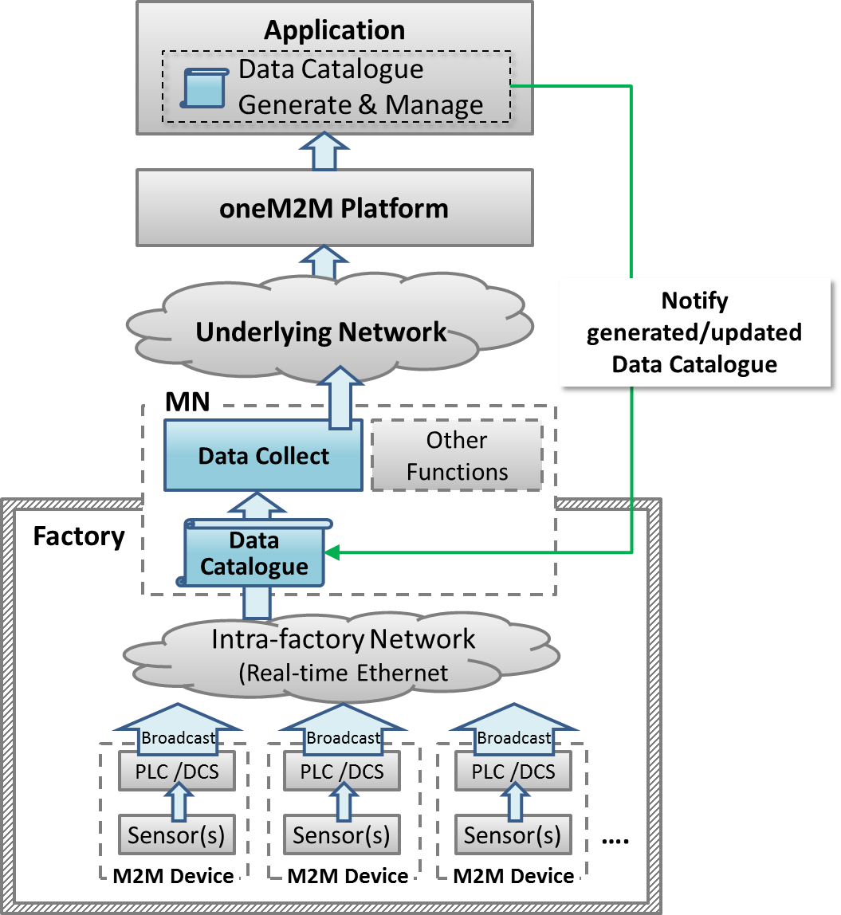

6.1.10 Potential requirements
- The gateway shall be able to collect data from field area network (e.g. industrial bus systems) according to data collection policy stored in the gateway.
- The data collection policy shall be manageable (configured, updated, deleted..) by M2M Applications on the M2M service platform

6.2 Integrity of Data Collection Monitoring

6.2.1 Description
In factories, a lot of data are created from Programmable logic controllers (PLCs) every second and data are utilised to monitor production lines. These data are available via industrial bus systems, e.g. Real-time Ethernet.
This type of data is called time series data which is a sequence of data points, typically consisting of successive measurements made over a time interval.
In order to monitor remotely, data are gathered by the oneM2M service platform that needs to interface with such industrial bus systems via M2M gateway (MN)s.
However, when some of data are lost due to some reasons, such as, damage of product line, temporal network delay, continuous network capacity overload and so on, some actions will be required immediately for safety. Furthermore, some considerations may be necessary, for example, switching to a new network service with more capacity, changing to the backup network, or adjusting data collecting policy for addressing an original reason of data loss. Other considerations may be effective when remote monitoring application inquires the oneM2M platform about condition of network traffic, e.g. temporal delay, continuous capacity overflow, or connection failure.
Similarly, from remote monitoring application, M2M gateway (MN) in each factory receives analysis result or some kinds of commands, which can be lost due to some reasons, such as, failure in analysis process, temporal network delay, or continuous network capacity overflow. M2M gateway (MN) can detect the loss when the analysis result or the commands in form of time series data, or it can detect potential loss with the help of monitoring condition of network traffic. When temporal network delay or continuous network capacity overflow occur, analysis result or commands may be lost. This loss will also require immediate decision and addressing a root cause.
This use case proposes that the oneM2M System shall be able to provide capability to collect, store time series data as well as monitor the integrity of data.
Moreover, the oneM2M System shall be able to provide the capability to monitor condition of network traffic.

6.2.2 Source
Hitachi and Huawei Technologies, CO., LTD

6.2.3 Actors
- PLC (Programmable logic controller): It controls sensors and devices in a production line according to embedded programs. It also has interface to Real-time Ethernet. It broadcasts data related to the production line to Real-time Ethernet.
- M2M Gateway (MN): It provides an interface from the Real-time Ethernet to the oneM2M System. The gateway collects and stores time series data from Real-time Ethernet then sends them to oneM2M service platform. It also receives analysis results or commands from oneM2M service platform. Furthermore, the gateway monitors the integrity of received analysis result or command by monitoring condition of network. It can detect the loss when the analysis result or the commands in form of time series data, or it can detect potential loss with the help of monitoring condition of network traffic when temporal network delay or continuous network capacity overflow occur.
- oneM2M service platform: It stores data gathered from gateway(s), and provides data to applications.
- Application: An M2M Application in the Infrastructure Domain monitors production lines by using collected data in oneM2M service platform and sends analysis results or commands depending on situations.
- Real-time Ethernet: A technology standardized in IEC TC65. Ethernet is used at physical layer. However the upper protocol is designed for industry purpose. In this use case, broadcast protocol is assumed.
- Internet connection: oneM2M service platform and gateway(s) are connected by the Internet physically.

6.2.4 Pre-conditions
- PLCs and gateway are connected to Real-time Ethernet. PLCs broadcast data to Real-time Ethernet. Gateway is configured to pick up necessary data from Real-time Ethernet.
- On top of the internet, VPN connection is established between oneM2M service platform and gateway(s).

6.2.5 Triggers
- The gateway starts to receive time series data.

6.2.6 Normal Flow
Gateway picks up time series data which is broadcasted at Real-time Ethernet. The gateway sends collected data to oneM2M service platform.
oneM2M service platform receives data, then stores and sends them to application.
The application monitors the integrity of time series data which is sent from gateway. If data loss occurs, application user will decide to send a command for some control action immediately. Then the application user will check the condition of network traffic to determine which means are used to solve the data loss.

6.2.7 Alternative flow
None

6.2.8 Post-conditions
None

6.2.9 High Level Illustration

6.2.10 Potential requirements

- The oneM2M System shall be able to collect, store time series data as well as monitor the integrity of these data.
- The oneM2M System shall be able to provide the capability to monitor condition of network traffic.

Time Series Data : is a sequence of data points which typically consist of successive measurements made over a time interval.
Editor’s Note: this definition of Time Series Data should be moved to TS-0011 Common Terminology.

6.3 Data Process for Inter-factory manufacturing

6.3.1 Description
To achieve remote manufacturing, numerous sensors are placed at product lines in factories and a significant amount of data is generated for monitoring purposes. This data is broadcast via intra-factory network (e.g. real-time Ethernet) through PLCs (Programmable logic controller) or DCSs (Distributed Control System), etc. For monitoring product lines efficiently and effectively, MNs (Middle Node which means the gateway) will selectively collect necessary data from intra-factory network, and then send this data to oneM2M services platform for use by manufacturing control applications. The data collection policy (named data catalogue) utilized at MNs is generated and managed by the application layer and may vary based on the specific monitoring purpose (e.g. collect only temperature data for purpose of monitoring device temperature; or collect both humidity and gas data for purpose of monitoring product quality). Also, data process functionality is needed at MNs in order to filter out error data or for summarizing percentage of data exceeding a threshold.
To respond rapidly to market changes, new factories may be needed for sufficient productivity. Thus inter-factory collaboration provides significant benefit and efficiency, which can be used in establishing a new factory where reference data catalogue can be used to establish new environment.

6.3.2 Actors
M2M Device: Sensors, controllers etc. located in factories (e.g. located at product lines) which measure and generate data. PLC (Programmable Logic Controller) /DCS (Distributed Control System) control sensors in production lines according to embedded programs. Both PLC and DCS can broadcast data related to production lines to intra-factory networks.
Intra-factory Network: In this use case, real-time Ethernet is assumed. It is standardized in IEC TC65 for which Ethernet is used at physical layer, but upper protocol is designed for industrial purpose. Meanwhile, broadcast protocol is assumed and data is broadcast with unique identifier/parameter (e.g. device ID).
oneM2M MN: Middle Node (gateway) provides an interface from the intra-factory network to oneM2M System. MN collects data from intra-factory network according to data catalogue, which is the data collection policy. The MN may process collected data and send the data to oneM2M services platform through underlying network.
oneM2M Services Platform: oneM2M services platform stores data gathered from MNs, and provides data to applications.
oneM2M Application: An oneM2M application in the Infrastructure Domain that monitors production lines for remote manufacturing control by using collected data from oneM2M services platform. For monitoring purposes, the M2M application defines and generates the data catalogue. Then, the application provides the data catalogue to MNs. M2M application also shares data catalogue in MNs with other factories.

6.3.3 Pre-conditions
PLCs or DCSs control sensors in production lines according to embedded programs. Both PLC and DCS can broadcast data related to production lines into an intra-factory network.
Real-time Ethernet is assumed as the intra-factory network. Meanwhile, broadcast protocol is assumed and in real-time Ethernet data is broadcast with unique identifier/parameter (e.g. device ID).

6.3.4 Triggers
A remote manufacturing control application generates a data catalogue for collecting data from product lines in factories.

6.3.5 Normal Flow
The normal flow steps are as follows:
- The application generates the data collection policy into a data catalogue, or updates the data catalogue when the monitoring purpose has changed. Then, the application notifies the data catalogue to MNs in a factory.
The application providing the data catalogue to the MNs may include the following condition:
- In some inter-factory collaboration cases, the application also provides the data catalogue to the MNs in other collaborating factories, e.g. a newly built factory.
- MNs start to selectively collect data from real-time Ethernet according to the data catalogue.
- OneM2M services platform receives, stores, and provides the data to manufacturing control applications.
- The application analyzes collected data for remote manufacturing control.

6.3.6 Post-conditions
The application utilizes (e.g. monitor and analyze) the data collected according to the data catalogue.

6.3.7 High Level Illustration

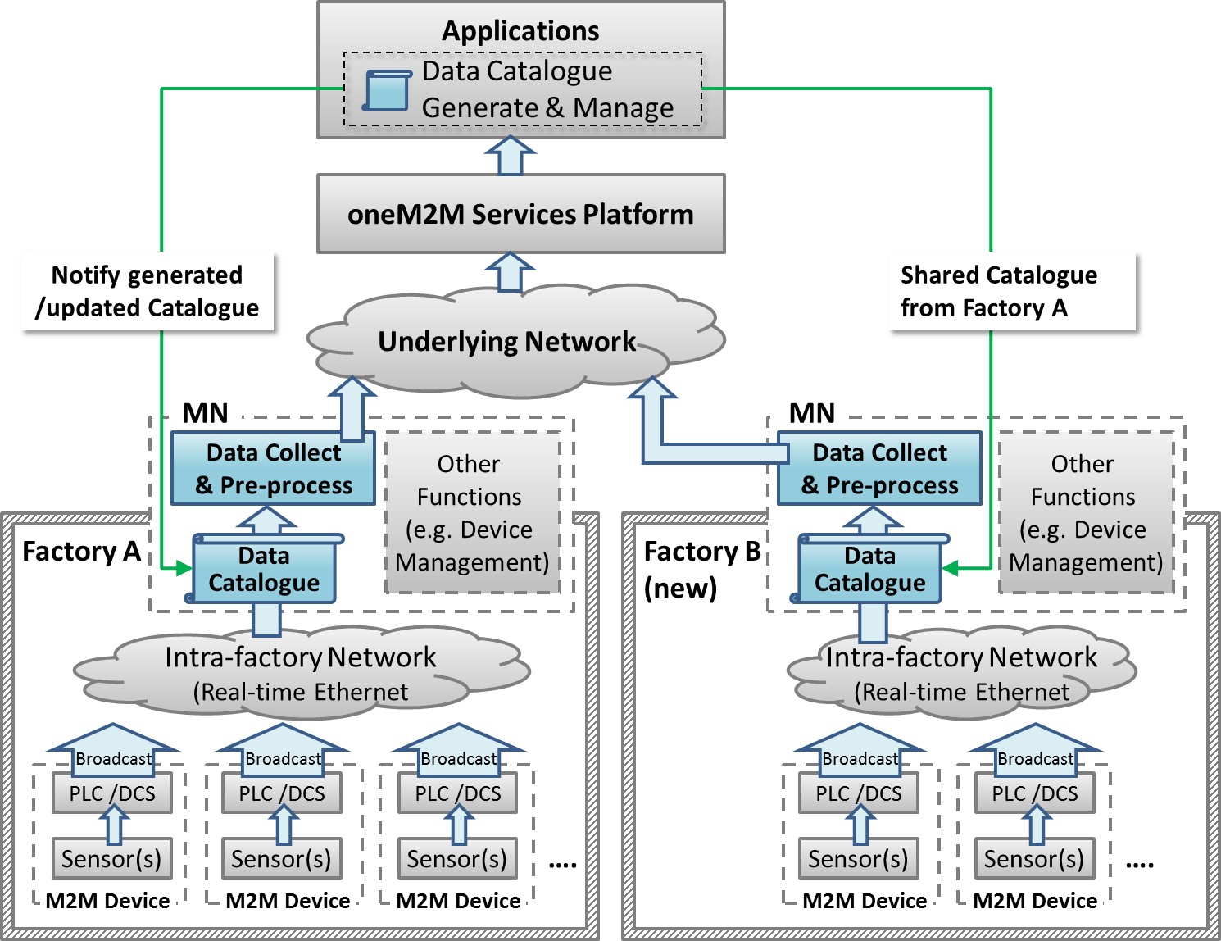

6.3.8 Potential requirements
- The oneM2M system shall be able to share data collection policies among different applications.

6.4 Aircraft construction and maintenance

6.4.1 Description
In aircraft construction, there are precise regulations that specify the kind of screw and the amount of force that must be used to join specific parts. When it comes to passenger aircraft, there are thousands of such screws that must be tightened and precisely documented. Joints on the wings naturally require a different amount of force than those on an aircraft window.
The tools are wifi-enabled and can identify their precise location on the shop floor. The position of the aircraft in the hangar is also fixed. With fixed coordinates and wifi connectivity, we know, for example, that a particular tool is located at the vertical stabilizer. Instructions that specify the force it should use to tighten screws can automatically be sent to the tool.

Although this use case focuses on aircraft construction and maintenance, the connected power tool technology is expected to be effective in more applications:
- Safety-critical work processes are closely monitored and analyzed. Anomalies are automatically detected through the central processing, analysis, and visualization of production process data in near real time. Role-specific alerts can be triggered automatically.
- The power tool fleet manager has an exact overview of the power tool fleet status and utilization thanks to central access to process data. Organizational processes can be triggered automatically.
- Quality controls are automated and shifted to earlier stages of the production process. For example, hundreds of thousands of torque recordings are made available in their entirety for quality monitoring.
- Indoor geofencing alarms ensure that power tools are used according to regulations. Not all tools are allowed for all production and maintenance steps, e.g. in aircraft maintenance. As soon as power tools know their location, they can switch off when used in error.

6.4.2 Source
An article “First European testbed for the Industrial Internet Consortium” in Bosch’s ConnectedWorld Blog
http://blog.bosch-si.com/categories/manufacturing/2015/02/first-european-testbed-for-the-industrial-internet-consortium/

6.4.3 Actors
- Power tools: People in a shop floor utilize them to tighten screws of the airplane. They are wifi-enabled, and can identify their precise location on the shop floor. They receive instruction for amount of power for tightening screws.
- Indoor localization technology: The technology is utilized to identify location of power tools.
- oneM2M service platform: oneM2M service platform receives location information of power tools, and sends them to application. It also receives instructions for amount of power for tightening screws and sends them to each one of power tools.
- Application: In this use case, the application is for aircraft construction and maintenance. It holds the position of the aircraft in the hangar, and matches them to location information of power tools to calculate which power tool is utilized for which part of the aircraft. Then, it gets instructions that specify the force a power tool should use to tighten screws by utilizing regulations that specify the kind of screw and the amount of force that must be used to joint specific parts. Finally, it sends the instructions to each one of power tools.
- Underline network: In this use case, wifi is assumed.

6.4.4 Pre-conditions
- Application holds the position of the aircraft in the hanger and regulations that specify the kind of screw and the amount of force that must be used to joint specific parts.
- Power tools are wifi-enabled.

6.4.5 Triggers
- A person on a shop floor starts to use a power tool.

6.4.6 Normal Flow
- The power tool identifies precise location information with use of indoor localization technology and sends the information to oneM2M platform.
- oneM2M service platform receives the location information and sends them to application.
- The application matches position of the aircraft in the hanger to location information of the power tool to calculate for which part of the aircraft the power tool is used.
- The application gets instruction that specify the force the power tool should be use to tighten screws by utilizing regulations that specify the kind of screw and the amount of force that must be used to join specific parts.
- The application sends the instruction to oneM2M platform.
- oneM2M platform receives the instruction and sends it to the power tool.
- The power tool uses the specified amount of force to tighten a screw.

6.4.7 Alternative flow
None

6.4.8 Post-conditions
None

6.4.9 High Level Illustration

6.4.10 Potential requirements

- The oneM2M System shall be able to support mechanism for the M2M Devices and/or Gateways to report their geographical location information to M2M Applications. (OSR-047)
- The oneM2M System shall support the ability for single or multiple M2M Applications to interact with a single or multiple M2M Devices/Gateways (application in the device/gateway) (OSR-009)

6.5 Real Time Data Collection

6.5.1 Description
In automated production with utilization of information and communication technology, behaviours of devices are controlled according to sensor values. In order to achieve adequate control, real-time Ethernet , with which sensors and devices are connected through controllers, are required to be provide real-time transmission and high-level of reliability. Real-time Ethernet is standardized in IEC TC65 and has characteristics such as the following.
・It enables real-time transmission by message priority control according to the importance of the data (network re-configuration communication is first, time series data is second, controlling commands for devices are third, and information data is forth priority). “Information data” contains movie, audio data, or objected sensor data. Higher priority data can be transmitted without interference from lower priority data. Priority of data depends not only on kind of data but also on source node or destination node. For example, although controlling commands for devices shall not be delayed, log information for logging servers does not require strict real-time transmission. Therefore there data have different value of priority.
・When real-time Ethernet is introduced, size and frequency of high priority data transmission are designed to make total volume of sent data not to exceed the capacity. Through this design process, real-time transmission is ensured and time series data and controlling commands are surely received within pre-defined intervals.
・It utilizes duplex LAN, which consists of two physically independent network paths between end-nodes, or dual Node to provide high-level of reliability.
・It achieves high level reliability on the basis of operations on ring based topologies and of following reconfiguration process. Each node connects to the ring via two ports. In the normal state, two neighboring nodes of the network become the Blocking State and cut off the connections logically between them to prevent loop. Each node monitors the neighboring segments including the blocking segment at all the time. If any segment of the network is disconnected, it will be back to a normal state within high-speed recovery time by automatically moving the blocking segments to each end of the faulty part thus isolating it.
・It broadcasts data to make each node have data, can enable autonomous de-centered distributed process where each node can keep working even if network failure has occurred somewhere, and can achieve high-level reliability.

This use case describes about M2M Gateway, which is oneM2M MN and sends data received from real-time Ethernet.
oneM2M MN shall be able to cope with temporal performance degradation of underlying network, temporal increase of amount of information data, and with temporal increase of amount of one data flow, which represents collection of data that have the same source node, priority, and kind of data. Therefore oneM2M MN shall be able to buffer data, transmit data in the order corresponding to priority, control transmission amount of data flow.

6.5.2 Source
None

6.5.3 Actors
- M2M Device: Sensors, controllers etc. located in factories (e.g. located at product lines) which measure and generate data. PLC (Programmable Logic Controller) /DCS (Distributed Control System) control sensors in production lines according to embedded programs.
- Real-time Ethernet: In this use case, real-time Ethernet with above characteristics is assumed. It is standardized in IEC TC65.
- oneM2M MN: Middle Node (gateway) provides an interface from the real-time Ethernet to oneM2M System. oneM2M MN is developed as dual Node (primary and secondary) to achieve high-level reliability.
- oneM2M Services Platform: oneM2M services platform stores data gathered from MNs, and provides data to applications.
- oneM2M Application: An oneM2M application in the Industrial Domain

6.5.4 Pre-conditions
PLCs or DCSs send and receive data through real-time Ethernet.

6.5.5 Triggers
Primary MN and secondary MN receive data, which is sent from PLCs or DCSs.

6.5.6 Normal Flow
1. Primary MN receives data and buffers it. If buffer is overflowed, data with lowest priority is discarded.
2. Secondary MN also receives data and buffers it. If buffer is overflowed, data with lowest priority is discarded.
3. Primary MN sends buffered data with highest priority to oneM2M platform. If multiple data has the highest priority, data flow of least recent transmitted is selected.
4. Secondary MN confirms status of primary MN, and primary MNs being active suppresses secondary MNs sending buffered data.
5. After pre-defined time-interval, primary or secondary MN receives another data from either PLCs or DCS.

6.5.7 Alternative flow
1. When secondary MN confirms that primary MN is not working, secondary MN sends buffered data.
2. After pre-defined time-interval, secondary MN receives another data from either PLCs or DCSs.

6.5.8 Post-conditions
When sending data process is not completed within time-interval or oneM2M platform does not receive data, primary or secondary MN sends data again by utilizing buffered data.

6.5.9 High Level Illustration

6.5.10 Potential requirements

- The oneM2M system shall be able to identify a series of data (e.g. time series data) and indicate individual data belong to this series.
- The oneM2M system shall be able to transmit data according to priority(CRPR-003)

6.6 Data Encryption in Industrial Domain

6.6.1 Description
In smart factories, data is essential for automation and efficient manufacturing execution. And data needs to be secured by measures such as authentication, authorization and encryption. As smart factories may connect to remote servers through multiple, partially external public networks, it cannot be assumed that these networks are secure. Encrypting data to avoid being stolen in external networks and protecting the integrity of data to avoid being modified are necessary for data security.
In industrial domain, the requirements of encryption are different (e.g. sensitive data such as confidential commercial secrets must be protected by strong encryption algorithms) and the capabilities of encryption/decryption also vary for different devices (e.g. for some low-cost devices, encryption/decryption with long key may cause heavy loads to their poor processing units). Thus each M2M application for smart factories needs proper encryption schemes to satisfy the various encryption requirements from application data, and meanwhile keep the encryption/decryption loads acceptable to constrained devices.
M2M applications classify data into various levels based on the importance of data and the capabilities of devices. In industrial domain, definition of sensitive data varies with products. For example, for manufactures of electric power grids, oil and gas, most data is sensitive, since it includes confidential state secrets (required by governments to provide strong protection); for makers of electronic products, information of product designs such as appearance or material is sensitive, since competitors stealing the product information will cause commercial damage. Based on common requirements from industrial domain, classification of application data is as follows, but not limit to below categories (dependent on M2M applications)
- Sensitive data: encryption strength are strongly required (e.g. with longer key or electronic signature); sensitive data includes such as,
  - Confidential commercial secrets (e.g. customer info, intellectual properties)
  - Confidential data from infrastructure manufacturers (e.g. waveform data for diagnose which is collected from devices in power grid)
  - Data for industrial control system (including filed bus, SCADA/Supervisory Control And Data Acquisition, controllers as PLC/Programmable Logic Controller or DCS/Distributed Control System)
  - Keys transmitted for encryption algorithms
- Normal data: encryption is recommended (optional) and proper applicable scheme should be adopted which is dependent on the capabilities of devices; normal data includes such as,
  - Status data for product line and device monitoring (e.g. device availability) in normal products manufacture which do not include any commercial secrets
  - Data for human resources monitoring and employee performance assessment (e.g. GPS information of workers collected from carried mobile tablets)
When various levels of application data in industrial domain is encrypted /decrypted based on its associated encryption scheme, the essential data is secured and the loads caused by normal data encryption are acceptable for constrained devices.

6.6.2 Actors
M2M Device: Machines, sensors, controllers etc. located in factories which measure and generate data. PLC /DCS control machines and sensors in production lines according to embedded programs.
Intra-factory Network: In this use case, intra-factory network is assumed managed by factory owners (different from Underlying Network operated by external parties).
oneM2M MN: Middle Node (gateway) collects data from intra-factory network and send the data to oneM2M services platform through underlying network.
oneM2M Services Platform: Support secure data transmission and mapping of application data levels to applicable encryption schemes.
oneM2M Application: Classify data based on sensitivity.

6.6.3 Pre-conditions
oneM2M Services Platform and security CSE inside M2M devices/MNs support various application data levels and mapping these levels to applicable encryption schemes.

6.6.4 Triggers
None.

6.6.5 Normal Flow
- The M2M application classifies data into various levels (e.g. into sensitive data and normal data),
- oneM2M Services Platform or security CSE inside M2M devices/MNs map these levels to applicable encryption schemes.
- Each pair of transmitter and receiver performs preparation procedure (e.g. share symmetric key and store it in respective storage inside nodes) before sending encrypted data.
- The transmitter (e.g. a server located at one end of the application) prepares the data for sending; encrypts the data based on its associated security level (with respective encryption algorithm, key length etc.).
- The encrypted data is sent to the receiver through intra-factory network and public underlying networks.
- The receiver (e.g. a machine located at the other end of the application) receives the data from transmitter and decrypts the data.

Post-conditions
The M2M application utilizes the decrypted data for smart manufacturing, such as executing orders, monitoring devices and diagnose, monitoring workers’ location and so on.

6.6.7 High Level Illustration
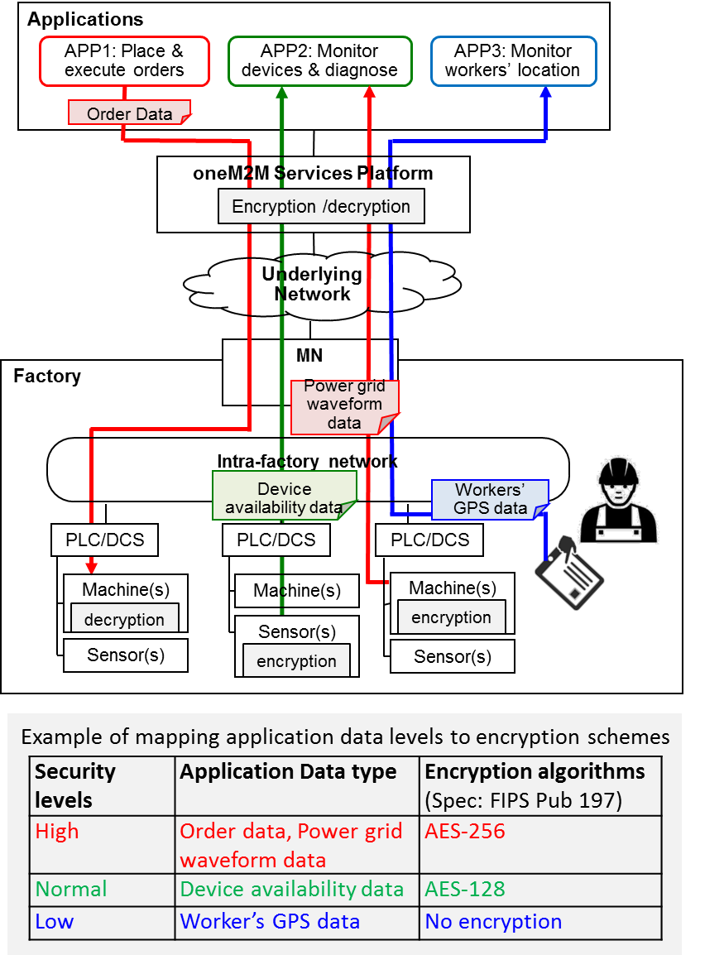

6.6.8 Potential requirements
- The oneM2M system shall support classification of application data by oneM2M applications into various security levels that are specified by oneM2M and support the mapping of these levels to applicable security capabilities.

6.7 QoS/QoI monitoring in industrial domain

6.7.1 Description
In factories, a lot of data are generated from M2M devices (e.g. machines and program logic controllers) and the data are delivered to the M2M gateway via industrial bus system, e.g. Real-time Ethernet. In addition, factory management application can get factory status information through oneM2M Service platform (Infrastructure Node) which gathers data from M2M gateways located in each factory domain.
In local industrial communications, data packet transmission between M2M gateway and M2M devices has real-time transmission characteristic delivered over Ethernet-based communication system. However, for allowing remote mechanisms (remote supervisory, operation, service), Wide Area Networks is composed of broad and heterogeneous communication technologies, e.g. digital wireless telecommunication systems (GSM-based, UMTS-based), digital wired telecommunication systems (ISDN, DSL).
In this environment, M2M gateway can use various telecommunication system to send and receive data packet from oneM2M service platform. In addition, according to industrial application service types, it requires hard real-time data delivery, soft real-time data delivery or real-time not requiring data delivery when it comes to communication between M2M gateway and oneM2M service platform.
If quality of service (QoS) required from the application could not be guaranteed, this situation limits service scenarios in industrial domains. In order to prevent this situation, M2M gateway can decrease the volume of data needs to send the oneM2M platform via data processing based on data catalogue. At the same time, if M2M gateway can monitor network environments, it can choose dynamically the network type or network provider who guarantees the required QoS.
In addition, for satisfying QoS, real-time data generated from M2M devices can be pre-processed/filtered based on data catalogue. In this situation, post-processed data is to include a kind of quality of information (QoI) and if QoI monitored and delivered to the oneM2M service platform, we can use this information for the further data processing in oneM2M platform.
This use case proposes that oneM2M system offers QoS/QoI Monitoring capabilities which include data accuracy, data age, cost, communication, encryption and so on.

6.7.2 Source
None.

6.7.3 Actors
- M2M Devices: Sensors, controllers etc. located in factories (e.g. located at product lines) which measure and generate data. PLC (Programmable Logic Controller) /DCS (Distributed Control System) control sensors in production lines according to embedded programs.
- Real-time Ethernet: A technology standardized in IEC TC65 for use in industrial control system.
- MN Gateway (MN): It provides an interface from the Real-time Ethernet to the oneM2M system. The gateway collects data from M2M devices which are connected via Real-Time Ethernet communication technology. The gateway can conduct data pre-processing/filtering based on the data catalog delivered from oneM2M service platform.
- oneM2M Service Platform (IN): It acts as oneM2M Infrastructure Node. It communicates with MNs in the remote industrial domains and gathers the data from the MN gateway. The data in oneM2M service platform can be delivered to the applications, e.g. factory monitoring application.
- Applications: An M2M application in application service provider domain. It conducts monitoring production lines and sends analysis results or alert message to factory administrator

6.7.4 Pre-conditions
- Devices (e.g. PLC, Machines) and gateway are connected to Real-time Ethernet. PLCs broadcast data to Real-time Ethernet.
- Gateway can have a capability of various network hardware interfaces (e.g. GSM-based, UMTS-based, ISDN, DSL) and also use various network service provider who guarantees the required QoS level.

6.7.5 Triggers
- Application initiates service which require QoS/QoI requirement (e.g. response time, data freshness).
- Application sends the QoS/QoI requirement to oneM2M platform.

6.7.6 Normal Flow
- oneM2M service platform requests QoS/QoI monitoring data from Gateway (MN) and based on this information, oneM2M service platform negotiates supported QoS/QoI parameter with application.
- For enabling end-to-end services, oneM2M service platform sends QoS requirement to the Gateway (MN). Based on QoS requirement, Gateway dynamically choose network type and network service provider who guarantees the required QoS level.
- In Gateway, QoS/QoI monitoring function can annotate data with quality information.
- After receiving data from Gateway (MN), oneM2M service platform can be further processing the data referring to the quality attributes.

6.7.7 Alternative flow
None

6.7.8 Post-conditions
None

6.7.9 High Level Illustration
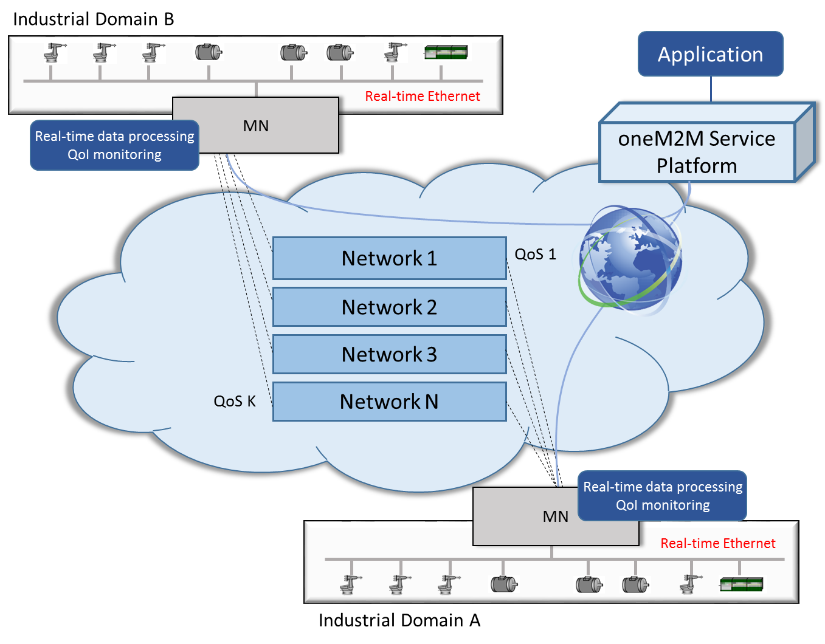

6.7.10 Potential requirements
- The oneM2M System shall support the inclusion of M2M Application’s QoS preference in service requests to Underlying Networks (OSR-038)
- The oneM2M System shall provide the capability for monitoring and describing data streams with associated attributes e.g. data freshness, accuracy, sampling rate, data integrity.

7 Overview of Potential Requirements
<Text> memo: Rearrange requirements in above use cases chapter in detail.

8 High Level Architecture
<Text> memo: Mapping objects in industrial domain (e.g. Production line, Programmable Logic Controller, Gateway, factory building, factory site, cloud server, headquarters, whole supply chain, ...) and objects in oneM2M (e.g. “ASN-AE”, “ADN-AE”, ...).

9 Security Analysis
<Text> memo: Security analysis of above use cases

10 Conclusion
<Text> memo: summarize above contents and potential requirements

Proforma copyright release text block
This text box shall immediately follow after the heading of an element (i.e. clause or annex) containing a proforma or template which is intended to be copied by the user. Such an element shall always start on a new page.
Notwithstanding the provisions of the copyright clause related to the text of the present document, oneM2M grants that users of the present document may freely reproduce the <proformatype> proforma in this {clause|annex} so that it can be used for its intended purposes and may further publish the completed <proformatype>.
<PAGE BREAK>

Annexes
Each annex shall start on a new page (insert a page break between annexes A and B, annexes B and C, etc.).
Use the Heading 9 style for the title and the Normal style for the text.
Annex <A>:
Title of annex (style H9)
<Text>
<PAGE BREAK>
Annex <B>:
Title of annex (style H9)
<Text>
B.1 First clause of the annex (style H1)
<Text>
B.1.1 First subdivided clause of the annex (style H2)
<Text>
<PAGE BREAK>

Annex <y>:
Bibliography
The annex entitled "Bibliography" is optional.
It shall contain a list of standards, books, articles, or other sources on a particular subject which are not mentioned in the document itself.
It shall not include references mentioned in the document.
Use the Heading 9 style for the title and B1+ or Normal for the text.
- <Publication>: "<Title>".
OR
<Publication>: "<Title>".
<PAGE BREAK>

History
This clause shall be the last one in the document and list the main phases (all additional information will be removed at the publication stage).
Publication history
V.1.1.1 | <dd Mmm yyyy> | <Milestone>

Draft history (to be removed on publication)
V.1.1.1 | <dd Mmm yyyy> | <CR ID> applied – <Summary of changes>

