

oneM2M
Technical Report
Document Number | TR-0022-V-0.4.0
Document Name: | Continuation & integration of HGI Smart Home activities
Date: | 2016-Febr-11
Abstract: | The document is a study of the continuation and integration of some HGI Smart Home activities into oneM2M, following the (PT2) HGI announcement of its closure by June 2016.  It includes the description of HGI SH deliverables versus the appropriate oneM2M deliverables for the integration of these HGI achievements.
Template Version:23 February 2015 (Dot not modify)

This Specification is provided for future development work within oneM2M only. The Partners accept no liability for any use of this Specification.
The present document has not been subject to any approval process by the oneM2M Partners Type 1. Published oneM2M specifications and reports for implementation should be obtained via the oneM2M Partners’ Publications Offices.

About oneM2M
The purpose and goal of oneM2M is to develop technical specifications which address the need for a common M2M Service Layer that can be readily embedded within various hardware and software, and relied upon to connect the myriad of devices in the field with M2M application servers worldwide.
More information about oneM2M may be found at: http//www.oneM2M.org
Copyright Notification
© 2015, oneM2M Partners Type 1 (ARIB, ATIS, CCSA, ETSI, TIA, TTA, TTC).
All rights reserved.
The copyright and the foregoing restriction extend to reproduction in all media.

Notice of Disclaimer & Limitation of Liability
The information provided in this document is directed solely to professionals who have the appropriate degree of experience to understand and interpret its contents in accordance with generally accepted engineering or other professional standards and applicable regulations. No recommendation as to products or vendors is made or should be implied.
NO REPRESENTATION OR WARRANTY IS MADE THAT THE INFORMATION IS TECHNICALLY ACCURATE OR SUFFICIENT OR CONFORMS TO ANY STATUTE, GOVERNMENTAL RULE OR REGULATION, AND FURTHER, NO REPRESENTATION OR WARRANTY IS MADE OF MERCHANTABILITY OR FITNESS FOR ANY PARTICULAR PURPOSE OR AGAINST INFRINGEMENT OF INTELLECTUAL PROPERTY RIGHTS. NO oneM2M PARTNER TYPE 1 SHALL BE LIABLE, BEYOND THE AMOUNT OF ANY SUM RECEIVED IN PAYMENT BY THAT PARTNER FOR THIS DOCUMENT, WITH RESPECT TO ANY CLAIM, AND IN NO EVENT SHALL oneM2M BE LIABLE FOR LOST PROFITS OR OTHER INCIDENTAL OR CONSEQUENTIAL DAMAGES. oneM2M EXPRESSLY ADVISES ANY AND ALL USE OF OR RELIANCE UPON THIS INFORMATION PROVIDED IN THIS DOCUMENT IS AT THE RISK OF THE USER.

Contents
Contents 3
1 Scope 4
2 References 4
2.1 Normative references 4
2.2 Informative references 4
3 Definitions, symbols and abbreviations 4
3.1 Definitions 4
3.2 Symbols 4
3.3 Abbreviations 4
4 Conventions 5
5 Technical description of HGI Smart Home activities in a generic IoT context 5
5.1 General Introduction to HGI SmartHome concepts and motivation of integration to oneM2M 5
5.2 Smart Home Architecture & requirements for Reference Points, HGI RD-036 5
5.3 Smart Device Template, HGI RD-050 7
6 Integration of HGI SH items into oneM2M work items 7
6.1 Update of oneM2M WIs already including some HGI SH inputs 7
6.2 other oneM2M WIs to be involved 8
6.3 Potential need for (a) new oneM2M WI(s) 9
Annex <A>: Follow-up of the integration 9
A.1 Check-list of HGI SH TF items integration into oneM2M 9
A.2 Roadmap 9
Annex <y>: Bibliography 10
History 11

1 Scope
The present document is a study of the continuation and integration of some HGI Smart Home activities into oneM2M, following the (PT2) HGI announcement of its closure by June 2016. It includes the description of HGI SH deliverables versus the appropriate oneM2M deliverables for the integration of these HGI achievements.
It intends to be used as a liaison working document with HGI about the status progress of this continuation and integration and is expected to be useful for both HGI and oneM2M to check that all technical items from HGI SH Task Force expected to be integrated are appropriately handled by oneM2M.

2 References
References are either specific (identified by date of publication and/or edition number or version number) or non-specific. For specific references, only the cited version applies. For non-specific references, the latest version of the referenced document (including any amendments) applies.

2.1 Normative references
Not applicable for a Technical Report.

2.2 Informative references
The following referenced documents are not necessary for the application of the present document but they assist the user with regard to a particular subject area.
[i.1] oneM2M Drafting Rules (http://member.onem2m.org/Static_pages/Others/Rules_Pages/oneM2M-Drafting-Rules-V1_0.doc)

3 Definitions, symbols and abbreviations

3.1 Definitions
For the purposes of the present document, the [following] terms and definitions [given in ... and the following] apply:
<defined term>: <definition>
<defined term>[N]: <definition> [N] identifies the external document which must be listed in Section 2 References.

3.2 Symbols
For the purposes of the present document, the [following] symbols [given in ... and the following] apply:
<symbol> <Explanation>
<2nd symbol> <2nd Explanation>
<3rd symbol> <3rd Explanation>

3.3 Abbreviations
For the purposes of the present document, the [following] abbreviations [given in ... and the following] apply:
<ABBREVIATION1> <Explanation>
<ABBREVIATION2> <Explanation>

4 Conventions
The key words “Shall”, ”Shall not”, “May”, ”Need not”, “Should”, ”Should not” in this document are to be interpreted as described in the oneM2M Drafting Rules [i.1]

5 Technical description of HGI Smart Home activities in a generic IoT context

5.1 General Introduction to HGI SmartHome concepts and motivation of integration to oneM2M
HGI Smart Home Task Force global objective was to defragment the Smart Home market and propose unified concepts identified as of prime importance around the Smart Home Gateway (SHGW) in order to facilitate the adoption and the use of such a product and related services in homes.
These concepts can be categorized into three main trends:
- modularity of the SHGW middleware to allow for flexible evolution of the services offered to the user;
- abstraction of the (possibly various) underlying connectivity technologies of the devices connected to the SHGW;
- identification of reference points that need to be standardized to forster open exposure to mutualized functions at the SHGW level as enablers for local or remote services.
As similar concepts are handled by oneM2M at the Sercice Layer level for IoT domain in general, some technical achievements from HGI SHTF can be merged into some of the oneM2M deliverables, which is a supplementary path towards more de-fragmentation of the IoT domain. The remaining subsections of this section 5 summarizes these HGI SHTF achievements to be considered.

5.2 Smart Home Architecture & requirements for Reference Points, HGI RD-036
Editor’s Note: explain the Smart Home issues and describe the HG-centered architecture, including the Device Abstraction Layer, that enables Smart Home. How it maps into oneM2M main architectural concepts. Also explain the reference points (identified in RD-036) that need to be standardized; how they may relate to oneM2M reference points / APIs.
HGI RD-036 deliverable presents the HGI reference architecture for the Smart Home Gateway (SHGW) and identifies the reference points that are at stake to deliver the smart home services, be it locally or remotely.
Figure 5.2-1 below shows this reference architecture, which is driven by the requirements of modularity and device abstraction allowed by the SHGW.
The Reference Points between the appliances (devices) and the SHGW and between the SHGW and the Cloud are designated by “RPx” on the Figure.

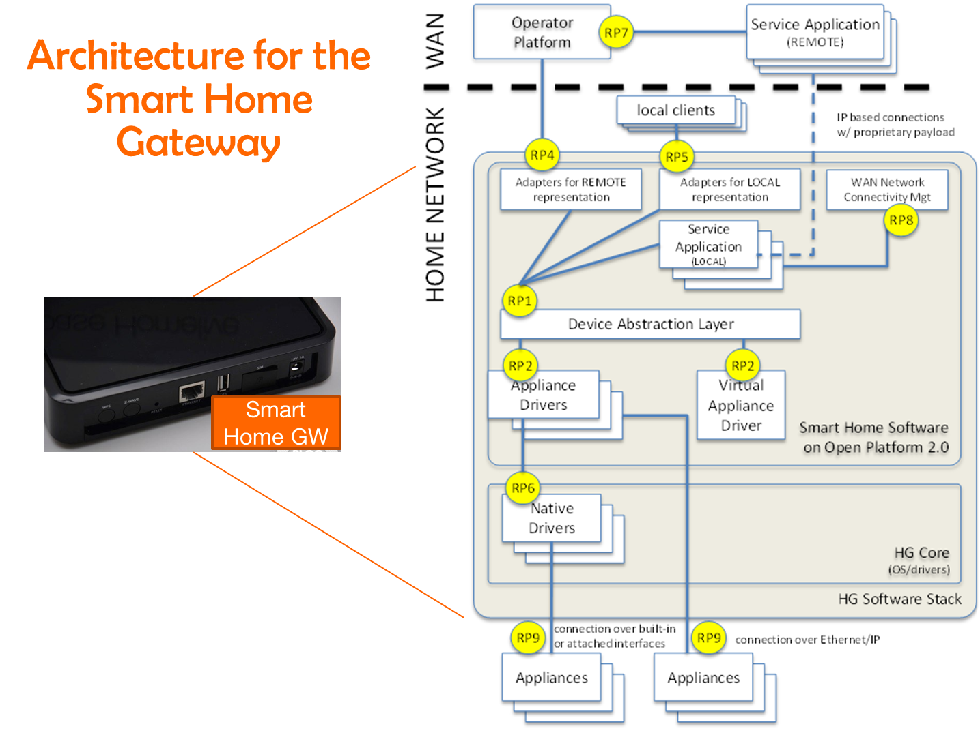
Figure 5.2-1 SHGW reference architecture and Reference Points

When comparing this architecture with the oneM2M architecture TS-0001, we can look at :
- the SHGW as a oneM2M Middle Node;
- RP4 as an example of oneM2M Mcc reference point,
- RP7 as an example of Mca reference point, and
- RP8 as an example of Mcn reference point.
This comparison is further detailed under Section 6.

As for the Device Abstraction Layer, this is further focused on Figure 5.2-2 below, which points out the disctinction between
- the “south” part of the DAL where the goal is to abstract the various device-connectivity technologies, and
- the “north” part of the DAL where the goal is to decouple the applicative-specific i.e.various applicative domains, with their specific ontologies, and unify the meaning of commands from the application side.
The purpose of device abstraction is indeed to allow creators of applications on SHGWs and/or in the Cloud to discover, identify, read, configure and manipulate devices, without needing to modify the software for each and every manufacturer model or type of wireless access, etc.
Figure 5.2-2 also shows the SDT (Smart Device Template) as part of this Device Abstraction process. This SDT is explained in more details under section 5.3.
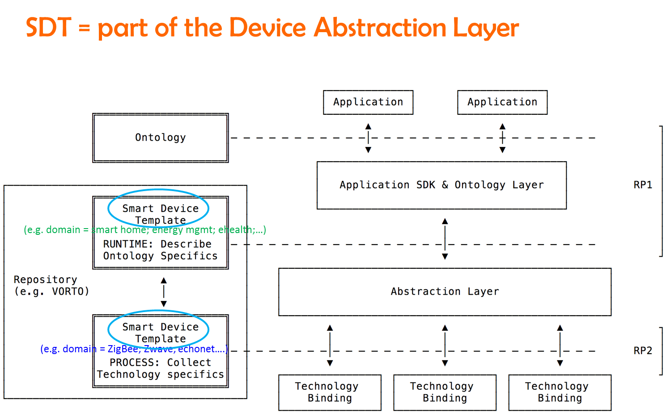
Figure 5.2-2 SDT place in the Device Abstraction process

5.3 Smart Device Template, HGI RD-050
The SDT (Smart Device Template, https://github.com/Homegateway/SmartDeviceTemplate/) is an initiative from HGI to find consensus amongst various SDOs and industry alliances to derive a common approach for device modelling. HGI and partners have the approach to agree on a set of automation commands, following a common syntax, which are sufficient to model most home appliance functions.
Every software developed for home gateways or internet-of-things gateways needs to be capable of using various different protocols (ZigBee, UPnP, EchonetLite, DECT ULE, etc) to interact with a range of devices designed for the home environment. This adds extreme overheads in integrating, checking and updating code. The purpose of SDT is to describe devices and device services in a way which is independent of the LAN technology, in a format which is convenient and reliable for integration in modern code (Java, C/C++, ...).
The key goals of the SDT are:
1) keep it simple, especially for manufacturers to contribute device information;
2) modularity for functions and device types;
3) make it easy for developers to create unified APIs;
4) be independent of underlying home-area network technologies;
5) enable extendibility of the system in place without service interruption;
6) allow a pass-through mechanism to enable use of proprietary or technology-specific functions.
The SDT approach is to define re-usable basic functions (or services), labelled "ModuleClass" in the figure below, which can represent the typical functions found in many home automation systems, such as "on/off", "dim a lamp", "receive events from binary sensor", "read data from sensor", etc. Each ModuleClass is composed of a (small) number of actions, datapoint read/write operations, or asynchronous events. For example, an "on/off" ModuleClass would consist perhaps of just one Action, but a "ReadKeypad" Action might have a number of possible events, each with some data value and (usually) a sequence-ID or timestamp start/stop to indicate when and how long each key was pressed.
More details about SDT can now be found in oneM2M TR-0017 section 5.1.3.
Also the ECHONET Consortium provided the mapping of the ECHONET-LITE technology in the SDT format; this contribution can be found at https://github.com/Homegateway/ECHONET-SDT-Contribution.

It should be noted that the HGI work on SDT is closely aligned with the work of OSGi Alliance (http://www.osgi.org) on Device Abstraction Layer (DAL). The OSGi Residential Specification Release 6 defines such a DAL that acts as an intermediate between technology-specifics of connected devices and embedded applications.
The next step on top of DAL within the OSGi Alliance is to specify further support for device abstraction using SDT.
In addition, OSGi Alliance already specified technologies binding for various connecting technologies such as USB, enOcean, UPnP,…

Furthermore, SDT-related discussions happened with a part of the Eclipse Foundation, in particular the Eclipse Vorto Project (http://eclipse.org/vorto). Vorto is an open source tool that allows to create and manage technology agnostic, abstract device descriptions, so called information models. Vorto and SDT information models are closely aligned in order to be able to exchange device descriptions in an interoperable way.

6 Integration of HGI SH items into oneM2M work items

6.1 Update of oneM2M WIs already including some HGI SH inputs
As introduced in Clause 5, the main HGI Smart Home technical achievements of interest for oneM2M include:
- HGI RD-036 deliverable, defining the Smart Home Architecture, published in Q4-2015
- SDT3.0 Smart Device Template, which is the meta-data model defined for modeling devices
The abstraction layer explicitely defined by these HGI deliverables can indeed be mapped to the oneM2M abstraction Common Services Entity at the Middle Node (MN-CSE), as illustrated in Figure 6.1-1 below derived from Figure 5.2-1.

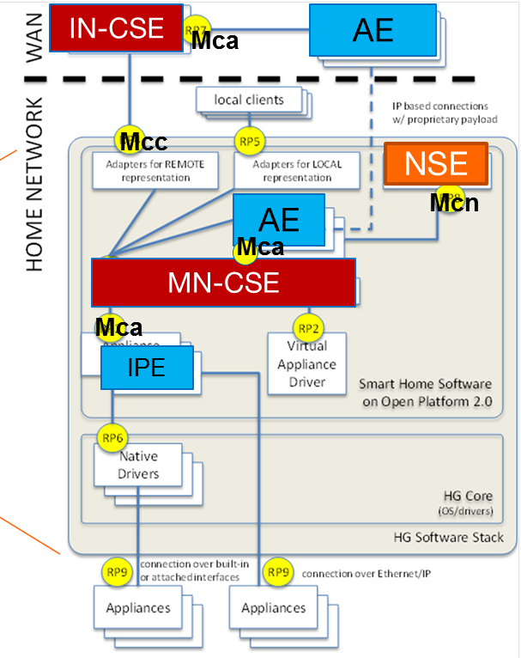
Figure 6.1-1 Mapping HGI SH architecture to oneM2M entities
The HGI Abstraction Layer concept is already mentioned in oneM2M TR-0007 (WI-0005) clause 6.2.2, and the updated SDT3.0 is described into details in TR-0017 (WI-0017) clause 5.1.3. From the latter, the SDT3.0 appears to be particularly relevant to be the oneM2M reference for the normative Home Information Model deliverable TS-0023 (also within WI-0017).
From Figure 5.2-2, the SDT is shown as a modeling template that can be used to :
- model devices in a unified way, be they technologyX-based or technologyY-based; for this part the SDT can be exposed to the appliances through a oneM2M IPE (Interworking Proxy Entity) via a oneM2M Mca instantiation that should meet the HGI requirements for RP1 Device Abstraction Layer (see Figure 5.2-1) as copied in Table 6.2-1 (under clause 6.2 below);
- provide a unified template for modeling devices for any applicative domain, thus facilitating cross-domain semantic interoperability; for this part, the SDT can be seen as the converging model to which various appliances data models from the industry can be mapped to.

6.2 other oneM2M WIs to be involved
The mapping of the SDT to oneM2M MN-CSE involves mapping of SDT elements into some oneM2M resource types e.g. semanticDescriptor, container of TS-0001 Release2 (WI-0025).
Editor’s Note: Additionnally, mapping HGI Reference Points to oneM2M Mca, Mcc, Mcn Reference Points involves careful analysis of TS-0004 Release2.
Editor’s Note: In particular HGI requirements for RP1 DAL (HGI RD-036 section 6.1) and RP1 access control (HGI RD-036 section 6.2) may be checked against TS-0001 and TS-0004 specifications for Mca.
Editor’s Note: HGI requirements for RP4 (HGI RD-036 section 6.5) may be checked against TS-0001 and TS-0004 specifications for Mcc.

6.3 Potential need for (a) new oneM2M WI(s)
In Clause 5.2, the HGI RP8 was compared to oneM2M Mcn, as a possible mean to re-use relevant functions from the fixed internet connection. Yet, currently the oneM2M Mcn is defined in relation with the mobile network, i.e. for the 3GPP triggering function. There may be a need to create a new oneM2M WI to describe Mcn in relation with fixed networks; such a new WI could be worked in close relation with e.g. BBF.

Annex <A>:
Follow-up of the integration

A.1 Check-list of HGI SH TF items integration into oneM2M
Editor’s Note: include a list of possible Action Items to be tracked.

A.2 Roadmap
Editor’s Note: indicate the timeline of the integration of HGI achievement into oneM2M (as the one suggested in the overview section of TP-2015-0773R02)

Annex <y>:
Bibliography
- <Publication>: “<Title>”.
OR
<Publication>: “<Title>”.

History
Publication history
V.1.1.1 | <dd Mmm yyyy> | <Milestone>

Draft history (to be removed on publication)
V.0.0.1 | 3rd August 2015 | Very first Draft for discussion at the HGI SH TF call on 5th August 2015, after creation of the oneM2M new WI-0043 (approved at TP18, on 22nd July 2015).
V.0.0.2 | 26th August 2015 | Revision taking into account comments received on the HGI diffusion list.
V.0.0.3 | 28th August 2015 | Revised version validated by the HGI SHTF call on 28th August. This version was presented at the MAS#18.2 call (31st August) which was a joint call with HGI SHTF.
V.0.0.4 | 7th September 2015 | Revised version to take into account comments from MAS#19 Monday opening session: section related to the management of the follow-up of the work is moved from the TR body to an annex.
V.0.1.0 | 14th September 2015 | Skeleton for TR-0022 (approved at oneM2M TP#19)
V.0.2.0 | 29th October 2015 | Integration of Approved contribution at MAS#19.2:  MAS-2015-0656, adding text under §5.1 and §5.2.
V.0.3.0 | 2nd December 2015 | Integration of the Approved contribution at MAS#20:  MAS-2015-0657R02, adding text under §6.1, 6.2, and 6.3.
V0.4.0 | 11th February 2016 | Integration of the Approved contribution at MAS#21:  MAS-2016-0040, adding text under §5.3

