

oneM2M
Technical Report
Document Number | TR-0023-V0.1.0
Document Name: | oneM2M and OIC Interworking
Date: | 2015-Sep-22
Abstract: | This technical report indentifies interworking scenarios and analyzes possible architectural solutions to support the interworking scenario.
Template Version:23 February 2015 (Dot not modify)

This Specification is provided for future development work within oneM2M only. The Partners accept no liability for any use of this Specification.
The present document has not been subject to any approval process by the oneM2M Partners Type 1. Published oneM2M specifications and reports for implementation should be obtained via the oneM2M Partners' Publications Offices.

About oneM2M
The purpose and goal of oneM2M is to develop technical specifications which address the need for a common M2M Service Layer that can be readily embedded within various hardware and software, and relied upon to connect the myriad of devices in the field with M2M application servers worldwide.
More information about oneM2M may be found at: http//www.oneM2M.org
Copyright Notification
© 2015, oneM2M Partners Type 1 (ARIB, ATIS, CCSA, ETSI, TIA, TSDSI, TTA, TTC).
All rights reserved.
The copyright and the foregoing restriction extend to reproduction in all media.

Notice of Disclaimer & Limitation of Liability
The information provided in this document is directed solely to professionals who have the appropriate degree of experience to understand and interpret its contents in accordance with generally accepted engineering or other professional standards and applicable regulations. No recommendation as to products or vendors is made or should be implied.
NO REPRESENTATION OR WARRANTY IS MADE THAT THE INFORMATION IS TECHNICALLY ACCURATE OR SUFFICIENT OR CONFORMS TO ANY STATUTE, GOVERNMENTAL RULE OR REGULATION, AND FURTHER, NO REPRESENTATION OR WARRANTY IS MADE OF MERCHANTABILITY OR FITNESS FOR ANY PARTICULAR PURPOSE OR AGAINST INFRINGEMENT OF INTELLECTUAL PROPERTY RIGHTS. NO oneM2M PARTNER TYPE 1 SHALL BE LIABLE, BEYOND THE AMOUNT OF ANY SUM RECEIVED IN PAYMENT BY THAT PARTNER FOR THIS DOCUMENT, WITH RESPECT TO ANY CLAIM, AND IN NO EVENT SHALL oneM2M BE LIABLE FOR LOST PROFITS OR OTHER INCIDENTAL OR CONSEQUENTIAL DAMAGES. oneM2M EXPRESSLY ADVISES ANY AND ALL USE OF OR RELIANCE UPON THIS INFORMATION PROVIDED IN THIS DOCUMENT IS AT THE RISK OF THE USER.

Contents
Contents 3
1 Scope 4
2 References 4
2.1 Normative references 4
2.2 Informative references 4
3 Definitions, symbols and abbreviations 4
3.1 Definitions 4
3.2 Symbols 5
3.3 Abbreviations 5
4 Conventions, 6
5 Technical Comparison of oneM2M and OIC 6
5.1 Introduction to OIC technology 6
5.1.1 Design Principle 6
5.1.2 System Architecture 6
5.1.2.1 Network Architecture 6
5.1.2.2 Device Architecture (Functional Block Diagram) 7
5.1.3 OIC Remote Access 7
5.1.3.1 Philosophy 7
5.1.3.2 Architecture 8
5.2 Technical Comparison 9
5.2.1 Discovery Model 9
5.2.2 Communication Model 10
5.2.3 Resource Representation 11
6 Scenarios for oneM2M and OIC Interworking 14
7. Possible Solutions for oneM2M and OIC Interworking 16
7.1. Functional Architecture for Interworking 16
7.2. Resource Model Mapping 17
8. Possible test scenario and cases for interworking between oneM2M system and OIC system 18
Proforma copyright release text block 18
Annexes 18
Annex <y>: Bibliography 19
History 19

1 Scope
This technical report describes:
- Technical comparison of oneM2M and OIC technologies
- Definition of an interworking architecture between oneM2M and OIC systems
- Identification of architectural solutions to address interworking. These solutions will include the following aspects:
- Resource mapping definitions
- Possible solutions for mapping between different schemas for each detail functions.
- Study developing test cases for interworking between oneM2M devices and OIC devices.
- Identification of possible impacts on existing oneM2M Technical Specifications as well as possible needs for new Technical Specifications
- Avoiding any overlaps with existing oneM2M work items..

2 References

2.1 Normative references
Not Applicable.

2.2 Informative references
[i.1] oneM2M Drafting Rules (http://member.onem2m.org/Static_pages/Others/Rules_Pages/oneM2M-Drafting-Rules-V1_0.doc)
[i.2] OIC Core Framework (http://openinterconnect.org/developer-resources/specs/ OIC_Core_Specification_Project_B_v0.9.9.pdf)
[i.3] OIC Remote Access (http://openinterconnect.org/developer-resources/specs/ OIC_RemoteAccess_Specification_Project_B_v0.9.9.pdf)
[i.4] XMPP Core (https://www.rfc-editor.org/rfc/rfc6120.txt )
[i.5] ICE (https://www.rfc-editor.org/rfc/rfc5245.txt )

3 Definitions, symbols and abbreviations
Delete from the above heading the word(s) which is/are not applicable.

3.1 Definitions
Clause numbering depends on applicability.
- A definition shall not take the form of, or contain, a requirement.
- The form of a definition shall be such that it can replace the term in context. Additional information shall be given only in the form of examples or notes (see below).
- The terms and definitions shall be presented in alphabetical order.
For the purposes of the present document, the [following] terms and definitions [given in ... and the following] apply:
Definition format
<defined term>: <definition>
If a definition is taken from an external source, use the format below where [N] identifies the external document which must be listed in Section 2 References.
<defined term>[N]: <definition>
example 1: text used to clarify abstract rules by applying them literally
NOTE: This may contain additional information.

Jabber ID – An Identifier/ username provided by the XMPP server to a User
OIC device : a logical entity which plays either OIC client or OIC server roles or both. OIC server hosts OIC resources and expose those for IoT service. OIC client accesses OIC server to manipulate OIC resources, i.e. monitoring & controlling
virtual OIC device : A representation of OIC device on IPE.

3.2 Symbols
Clause numbering depends on applicability.
For the purposes of the present document, the [following] symbols [given in ... and the following] apply:
Symbol format
<symbol> <Explanation>
<2nd symbol> <2nd Explanation>
<3rd symbol> <3rd Explanation>

3.3 Abbreviations
Abbreviations should be ordered alphabetically.
Clause numbering depends on applicability.
For the purposes of the present document, the [following] abbreviations [given in ... and the following] apply:
Abbreviation format
<ABBREVIATION1> <Explanation>
<ABBREVIATION2> <Explanation>
<ABBREVIATION3> <Explanation>
RAE – Remote Access Endpoint
JID – Jabber ID
For further list of abbreviations refer the OIC specifications [i.2] and [i.3]

4 Conventions,
The key words “Shall”, ”Shall not”, “May”, ”Need not”, “Should”, ”Should not” in this document are to be interpreted as described in the oneM2M Drafting Rules [i.1]

5 Technical Comparison of oneM2M and OIC
This clause will include the introduction of OIC technology and the comparison betwwn OIC and oneM2M technology.

5.1 Introduction to OIC technology
This section describes the introduction to OIC as basic information for comparision between oneM2M and OIC. More details of OIC is described in [i.2]

5.1.1 Design Principle
The main objective of OIC is to create an interoperable framework for interaction between devices within local network and remote network. In OIC architecture, entities in physical world for e.g. bulb are represented as resources with their unique URIs and supported interfaces that enable RESTful operations on these resources. OIC defines the notion of a roles for devices. A device having Client role initiates a RESTful operation with a device having Server role which responds to the operation. The interaction between OIC Client and Server are depicted as in the figure 1.
Figure 1: OIC Architectural Interaction

5.1.2 System Architecture

5.1.2.1 Network Architecture
OIC System is a network of devices connected peer to peer or via an infrastructure device. Devices in an OIC network can play the role of an OIC Client or an OIC Server or both. Figure 2 represents an OIC network with peer to peer connected devices.
Figure 2: OIC Network

5.1.2.2 Device Architecture (Functional Block Diagram)
OIC Device architecture encompasses the functionality required for OIC operations. Figure 3 below depicts the same. L2 connectivity includes various connectivity like Wi-Fi, BT etc. Network could be either IPv4 or IPv6 based. Transport uses either UDP or TCP. OIC framework provides the core functions needed by an OIC device for e.g. discovery etc. The application profiles are specific to a domain of operation for e.g. Smart Home.
Figure 3: Functional Block Diagram

5.1.3 OIC Remote Access

5.1.3.1 Philosophy
OIC Remote Access is accomplished using XMPP and ICE standards. XMPP Clients in an OIC network interact with XMPP server hosted in the cloud. XMPP clients are configured with an address and account of the XMPP server. XMPP server maintains account information and account policies. The XMPP stanzas (messages) exchanged between XMPP server and XMPP Client includes OIC CoAP messages in its payload. The receiving end decodes it and retrieves the message. For Peer to Peer communication ICE standard is proposed which will be fully specified in later releases.

5.1.3.2 Architecture
Figure below shows the OIC Remote Access Architecture with one XMPP server.
Figure 4: OIC Remote Access Architecture

RAE Server is an OIC Server with XMPP client functionality. RAE client is an OIC Client with XMPP client functionality. Figure 5 indicates a basic flow.
- A user account is created offline on the XMPP server.
- Both RAE Server and RAE client are provisioned with the details of XMPP server, JID and passphrase.
- RAE Server is authenticated with XMPP server and bound using the full JID
- RAE Server updates its presence status and retrieves roster to keep track of the presence information of devices in its roster
- RAE Client is also authenticated with XMPP server and bound using the full JID
- RAE client updates its presence status and retrieves roster to keep track of the presence information of devices in its roster
- Once the RAE Client knows RAE Server to communicate with it will establish an In-Band byte stream with it and exchange stanzas
- These stanzas contain the information like URL to OIC resource, method to invoke, and json payload for the request when needed

Figure 5: Discovery flow in case of Remote Access
More details of OIC Remote Access are described in [i.3]
Sleeping devices are handled using Resource Directory. For details please refer [i.2]
Editors Note: OIC Security details to be submitted in a separate contribution

5.2 Technical Comparison
This clause describes the technical comparison of oneM2M and OIC. Both oneM2M and OIC adopt ROA(Resource Oriented Architecture) design principles which expose their functionalities by means of resoruces and manipulated with RESTful APIs. However, There are some points of comparison between oneM2M and OIC from the perspective of discovery model, communication model, and resource representation.

5.2.1 Discovery Model
The table 5.2.1-1 demonstrates the comparison between oneM2M and OIC with respect to discovery model.
Table 5.2.1-1 The Comparison of Discovery Model of oneM2M and OIC System
 | oneM2M | OIC
Resource Discovery | Resource discovery supported, which allows discovering of resources residing on a CSE.  Using the Filter Criteria parameter for discovery allows limiting the scope of the results. (e.g. resource types, creation time, maximum size and matching string)  The discovery message is sent over unicast for a target CSE.  oneM2M supports resource announcement which means original resource can be announced to one or more remote CSEs, which facilitate resource discovery. | Resource discovery supported, which allows discovering of resources residing on OIC device.  OIC core resource, /oic/res maintains the list of its referenced resources that are discoverable on OIC device.  The discovery message may be sent multicast for multiple OIC devices (default) or unicast for a single OIC device.
Peer Discovery | Peer discovery not supported.  oneM2M basically needs to be pre-provisioned which means AE/CSE must know the peer IP address it will register to. | Peer discovery supported.  OIC device sends CoAP multicast message over the IP network to discover peers. For HTTP, it use Multicast DNS(mDNS).

5.2.2 Communication Model
The table 5.2.2-1 demonstrates the comparison between oneM2M and OIC with respect to communication model.
Table 5.2.2-1 The Comparison of Communication Model of oneM2M and OIC System
 | oneM2M | OIC
Registration Need | Each entity in oneM2M must perform registration procedure which establishes a relationship between CSEs/AE allowing them to exchange information.  Registree-Registrar relationship produces routing path when transferring messages. | OIC does not have the concept of registration between OIC devices.
Communication Flow | Based on RESTful stateless request-response paradigm  Request message flow occurs from the Originator CSE to the Hosting CSE which generates Hop-by-Hop data delivery.  Blocking and non-Blocking mode supported | Based on RESTful stateless request-response paradigm  OIC client and OIC server directly communicate without involvement of any other OIC entity.  OIC supports remote access (RA) which enables communication between OIC client and OIC server where each device is in a different network via connection broker server.

The figure 5.2.2-1 and figure 5.2.2-2 illustrate message delivery in each oneM2M and OIC system and show comparison between oneM2M and OIC system communication model.

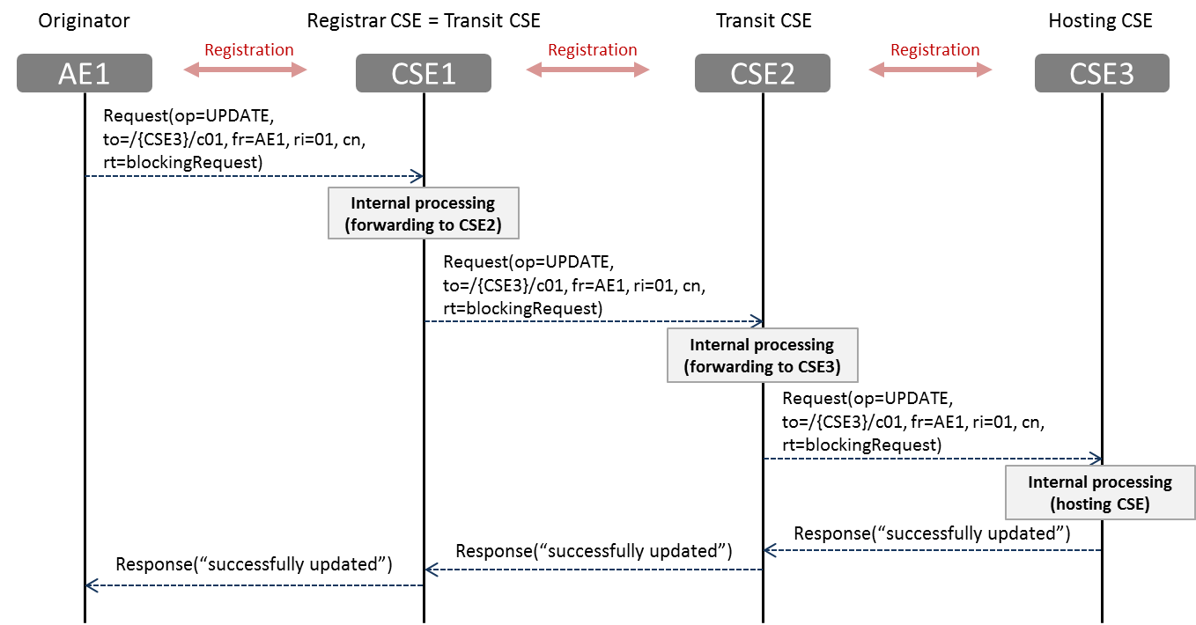
Figure 5.2.2-1 oneM2M Reqeust-Response communication model (Multi-Hop)

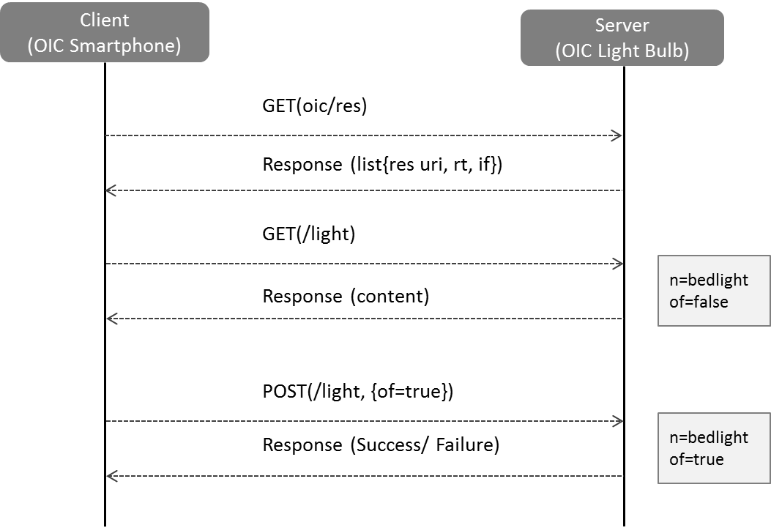

Figure 5.2.2-2 OIC Peer-to-Peer communication model

5.2.3 Resource Representation
The table 5.2.3-1 demonstrates the comparison between oneM2M and OIC with respect to resource representation.
Table 5.2.3-1 The Comparison of Resource Representation of oneM2M and OIC System
 | oneM2M | OIC
Functionality exposed by Resources | oneM2M defines common M2M services which can be used for any vertical application service domains.  oneM2M common services are exposed via oneM2M defined resource types which comprises of <container>, <group>, <locationPolicy>, <subscription>, <request>, <delivery> etc.  Based on the device capability, oneM2M entity can be represented as CSE or AE.  oneM2M resource model provides common service layer level interoperability. | OIC represents an entity of the physical world as a OIC device (e.g. temperature, an electric light or a home applicance) using resource model.  OIC device includes the base/core functionality and device specific functionality which is represented by OIC defined resource types.  OIC resource model provides application profile level interoperability among OIC Devices.
Resource Structure | Hierarchical resource structure  <CSEBase> represents the oneM2M CSE and is the the root for all the resources.  oneM2M resources have a parent-child relationships.  Each resource in oneM2M entity can be accessed via both structured (hierarchical) URI as well as un-structured (flat) URI. | Flat resource structure  OIC device consists of core resource and device specific resource.  Core resource has pre-defined resource name which can be accessed via fixed URI  Device specific resource has variable resource name and represents device specific functionality (e.g. binary switch, brightness etc.)

Assuming a light bulb is modelled as oneM2M device or OIC device in each domain, the table 5.2.1-2 and 5.2.1-3 show examples about oneM2M and OIC resource representation respectively.

Table 5.2.3-2 oneM2M <AE> resource (XSD example)
<xs:schema xmlns=http://www.w3.org/2001/XMLSchema targetNamespace="http://www.onem2m.org/xml/protocols"
xmlns:m2m=http://www.onem2m.org/xml/protocols xmlns:xsi="http://www.w3.org/2001/XMLSchema-instance"
elementFormDefault="unqualified" xmlns:xs="http://www.w3.org/2001/XMLSchema">

<xs:element name="AE">
<xs:complexType>
<xs:complexContent>
<!-- Inherit common attributes for announceable Resources -->
<xs:extension base="m2m:announceableResource">
<xs:sequence>
<!-- Resource Specific Attributes -->
<xs:element name="appName" type="xs:string" minOccurs="0" />
<xs:element name="App-ID" type="xs:string" />
<xs:element name="AE-ID" type="m2m:ID" />
<xs:element name="pointOfAccess" type="m2m:poaList" minOccurs="0" />
<xs:element name="ontologyRef" type="xs:anyURI" minOccurs="0" />
<xs:element name="nodeLink" type="xs:anyURI" minOccurs="0" />
<xs:element name="requestReachability" type="xs:boolean" />

<!-- Child Resources -->
<xs:choice minOccurs="0" maxOccurs="1">
<xs:element name="childResource" type="m2m:childResourceRef" minOccurs="1" maxOccurs="unbounded" />
<xs:choice minOccurs="1" maxOccurs="unbounded">
<xs:element ref="m2m:container" />
<xs:element ref="m2m:group" />
<xs:element ref="m2m:accessControlPolicy" />
<xs:element ref="m2m:subscription" />
<xs:element ref="m2m:pollingChannel" />
<xs:element ref="m2m:schedule" />
</xs:choice>
</xs:choice>
</xs:sequence>
</xs:extension>
</xs:complexContent>
</xs:complexType>
</xs:element>
</xs:schema>

Table 5.2.3-3 OIC light device resource (JSON example)
[{
"di": "example_device_id",
"links": [
{ "href": "/oic/d",
"rt": "oic.d.light",
"if": "oic.if.r",
"rel": "hosts"},
{ "href": "/myLightSwitch",
"rt": "oic.r.switch.binary",
"if": "oic.if.a",
"rel": "hosts"},
{ "href": "/myLightBrigtness",
"rt": "oic.r.light.brightness",
"if": "oic.if.a",
"rel": "hosts"}
]
}]
{
"n": "myRoomLightDevice",
"rt": “oic.d.light",
"if": "oic.if.r",
“di": "example_device_id“,
"icv": "oic.1.5"
}
{
"n": MyRoomLightSwitch",
"rt": "oic.r.switch.binary",
"if": "oic.if.a",
"id": "b.switch_TF38_3",
"value": "true"
}
{
"n": MyRoomLightBrightness",
"rt": "oic.r.light.brightness",
"if": "oic.if.a",
"id": “light_brightenss_TF38_3",
"value": 30
}

6 Scenarios for oneM2M and OIC Interworking
This clause describes the scenarios for oneM2M and OIC system interworking. Figure 6-1 provides an overview of possible interworking scenarios. Individual scenarios are further described below in detail.

Figure 6-1: Interworking Overview
In Figure 6-2 OIC network is deployed in the field domain. This OIC network communicates with oneM2M network in the Infrastructure domain. oneM2M service controller (oneM2M device) remotely controls the OIC devices in field domain through the oneM2M Infrastructure domain. The demarcation between domains is represented using the dotted vertical line. For e.g. a user buys a new Samsung Washer (OIC device) and connects to a Gateway (IPE) subsidized by oneM2M service provider platform in order to receive their oneM2M based IoT service.
Figure 6-2: OIC devices in the field domain connect to oneM2M infra domain and get controlled by oneM2M system

In Figure 6-3 both OIC network and oneM2M network are deployed in the field domain. These networks communicate with each other using the oneM2M Infrastructure domain. For e.g. an Air Conditioner (OIC field domain Device) could get the price data from the SmartEnergy service (oneM2M field domain) and if the electricity price is too high, it will change to energy-saving mode.
Figure 6-3: Interworking between OIC field domain and oneM2M field domains through oneM2M infrastructure domain
In Figure 6-4 two OIC networks are deployed in the field domain. These networks communicate with each other using the oneM2M Infrastructure domain. Alternatively OIC Remote Access network could be used to communicate between the two OIC networks in field domain. For e.g. SmartHome (OIC field domain) and Healthcare system (OIC field domain) are connected with oneM2M service provider infrastructure. By using oneM2M infrastructure network, devices in both OIC domains can transfer information between them.
Figure 6-4: Interworking between OIC field domains thru oneM2M infrastructure domain
In figure 6-5 an OIC network and an oneM2M network are deployed in the field domain. These two networks communicate directly with each other without any support from the infrastructure domain. For e.g. a user installs new smart bulb (OIC device) in home. This new bulb could connect to oneM2M devices in home and could be controlled by a oneM2M switch. This peer to peer scenario may not be realizable as oneM2M devices always need to be registered to oneM2M Infrastructure domain CSE.
Figure 6-5: Interworking between OIC field domains and oneM2M field domains locally
Scenarios where OIC device controls oneM2M devices is considered to be in the scope of OIC specifications and will not be defined here.

7. Possible Solutions for oneM2M and OIC Interworking
This section presents tentative solutions for oneM2M and OIC interworking and provides 1) Functional architecture and 2) Operation procedures. The first presents the interworking principle with main entities. The second describes the operation procedures, i.e. interaction between main entities. This functional architecture can address all scenarios from clause 6 where OIC devices are controlled by the oneM2M system.

7.1. Functional Architecture for Interworking
OIC interworking scheme is based on Interworking Proxy Entity (IPE), which, as an intermediary, facilitates oneM2M & OIC interworking by translating oneM2M and OIC resources. IPE interacts with OIC devices and expose those as virtual oneM2M devices, i.e. oneM2M resources. oneM2M CSE accesses IPE via oneM2M interface to manipulate virtual oneM2M devices, then the resulting representation change is reflected to the corresponding OIC devices via OIC interface.
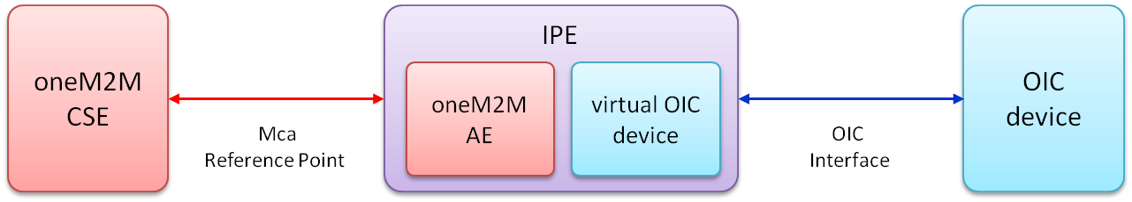
Figure 7-1 Functional Architecture with IPE
The main entities and their characteristics are as below.
- IPE : a specialized AE, characterized by the support of a non-oneM2M reference point, and by the capability of remapping the related data model to the oneM2M resources exposed via the Mca reference point
- oneM2M CSE : oneM2M common service entity (CSE)
- OIC device : a logical entity which plays either OIC client or OIC server roles or both. OIC server hosts OIC resources and expose those for IoT service. OIC client accesses OIC server to manipulate OIC resources, i.e. monitoring & controlling.
The figure 7-2 demonstrates a possible deployment model which describes the main entities and their Main entities and their interworking via reference points.
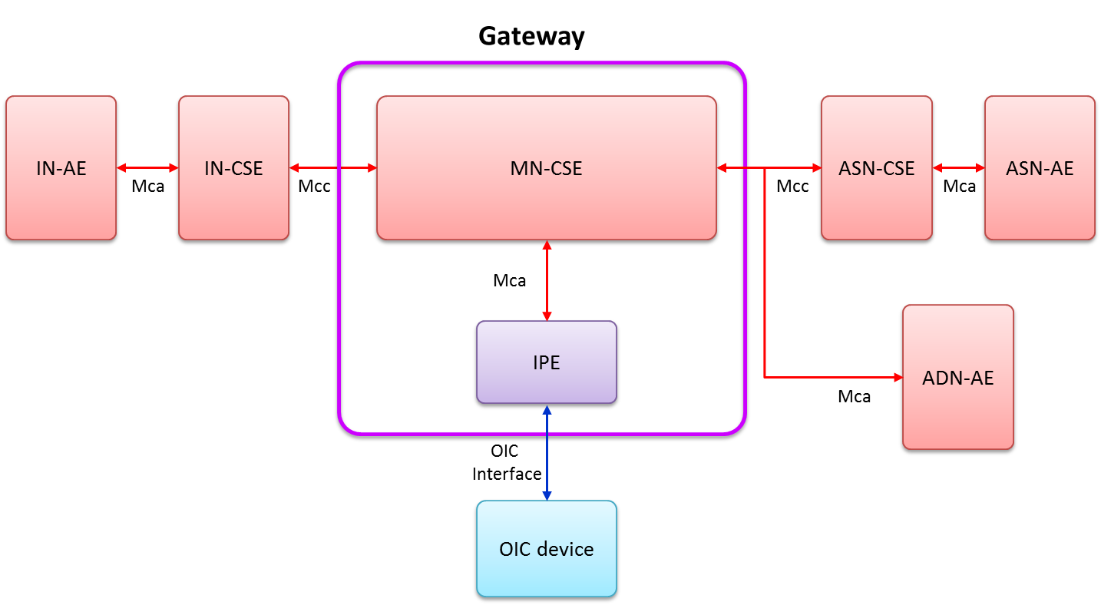
Figure 7-2 Deployment model based on functional architecture

7.2. Resource Model Mapping
Conceptually IPE performs 3 functions. First IPE interacts with OIC devices to retrieve the OIC resource. Second IPE translates OIC resources to oneM2M resources and vice versa. Third IPE exposes those a virtual OIC device into oneM2M system We summarize those functions as below.
- virtual OIC device in IPE: IPE performs OIC procedures (e.g. discovery or registration) to replicate (virtual) OIC device in itselt. The original and the virtual OIC device are bound such that they are synchronized, i.e. they have the same resource representation. A change in representation in one device is reflected in the other and vice versa.
- oneM2M AE in IPE: IPE mirrors the virtual OIC device into a virtual oneM2M AE by resource mapping.
- oneM2M service with oneM2M AE : IPE exposes oneM2M AEs for IoT services via Mca interfaces. oneM2M application access a oneM2M AE through the connected CSE in between and manipulate its resources (e.g. controlling & monitoring). The resulting representation change is reflected to the virtual OIC device via intra IPE translation, then the original device is synchronized by binding.
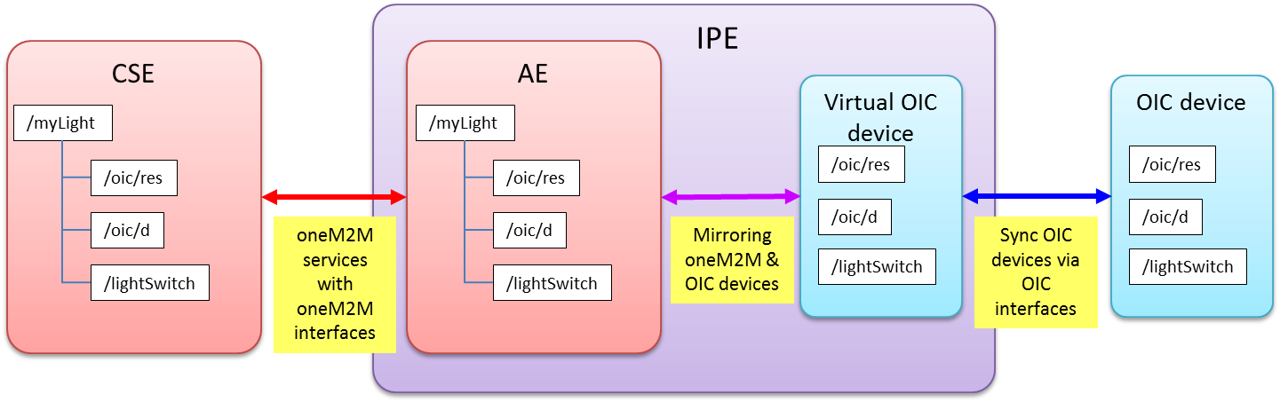
Figure 7-3 IPE functions with resource translation

8. Possible test scenario and cases for interworking between oneM2M system and OIC system

Proforma copyright release text block
This text box shall immediately follow after the heading of an element (i.e. clause or annex) containing a proforma or template which is intended to be copied by the user. Such an element shall always start on a new page.
Notwithstanding the provisions of the copyright clause related to the text of the present document, oneM2M grants that users of the present document may freely reproduce the <proformatype> proforma in this {clause|annex} so that it can be used for its intended purposes and may further publish the completed <proformatype>.
<PAGE BREAK>

Annexes
Each annex shall start on a new page (insert a page break between annexes A and B, annexes B and C, etc.).
Use the Heading 9 style for the title and the Normal style for the text.
Annex <A>:
Title of annex (style H9)
<Text>
<PAGE BREAK>

Annex <y>:
Bibliography
The annex entitled "Bibliography" is optional.
It shall contain a list of standards, books, articles, or other sources on a particular subject which are not mentioned in the document itself.
It shall not include references mentioned in the document.
Use the Heading 9 style for the title and B1+ or Normal for the text.
- <Publication>: "<Title>".
OR
<Publication>: "<Title>".
<PAGE BREAK>

History
This clause shall be the last one in the document and list the main phases (all additional information will be removed at the publication stage).
Publication history
V.1.1.1 | <dd Mmm yyyy> | <Milestone>

Draft history (to be removed on publication)
V0.0.1 | 25 Aug 2015 | First draft uploaded
V0.1.0 | 22 Sep 2015 | Agreed contributions from TP19  ARC-2015-2125R02_Introduction to OIC technology  ARC-2015-2135R04_Scenarios for oneM2M and OIC Interworking  ARC-2015-2139R02_Technical Comparison of oneM2M and OIC in Clause5.2  ARC-2015-2118R04_Functional Architecture for oneM2M-OIC interworking

